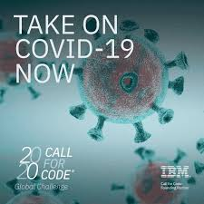

**Ready Reckoner - COVID-19 Crisis Communication Chabot**

***Implemented by Cognizant Employees (Team Name: - Tech Genius)***

***Amit Kumar Ghosh (Email: Amit.KumarGhosh@cognizant.com)***

***Soumadip Roy (Email: Soumadip.Roy@cognizant.com)***

***Ankika Karmakar (Email: Ankika.Karmakar@cognizant.com)***

***Parama Banerjee (Email: Parama.Banerjee2@cognizant.com)***

***Kritika Joshi (Email: Kritika.Joshi@cognizant.com)***

**TABLE OF CONTENTS**

Overview 3

Problem Statement 3

How can IBM Cloud Service help 3

Video 4

The Idea 4

How do Chatbots work 4

Architecture 5

Roadmap 9

Technology 9

Getting started 10

Take on Covid-19 with the Next Steps 22

Disclosures 30

Scope for Enhancement 30

## Overview

This Document will provide the information how to implement a chabot using IBM Cloud services to provide free crisis communication amid COVID-19 pandemic.

## Problem Statement

In times of crisis, communications systems are often overwhelmed with people trying to find basic information about testing, symptoms, community response, and other resources. When communication lines get clogged, people who need real help can't get through. Chatbots help respond to tens, even hundreds, of thousands of messages a day.

## How can IBM Cloud Service help

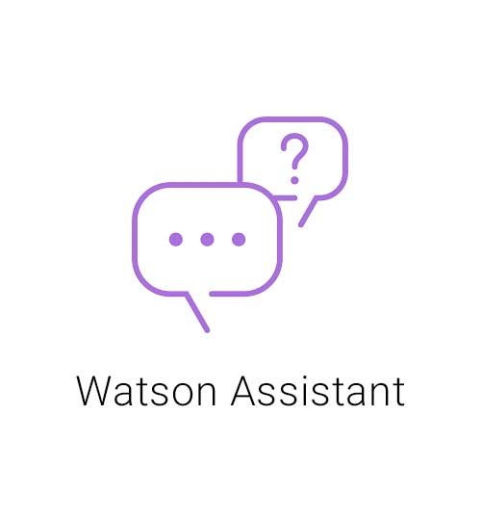

IBM Watson Assistant service is an AI service in IBM Cloud that helps you build, train, and deploy conversational interactions into any application, device, or channel. Creating a Chabot using Watson Assistant can help address the issues that our users face while trying to gather accurate, relevant information. Whether you're trying to learn the latest news about Covid-19 or learn where there's testing in your area, a Chabot can play a major role in helping communities quickly understand crucial information and free up customer service resources to focus on higher-level issues. This document shows you how to create a crisis communication Chabot using IBM Watson Assistant.

Watson’s assistant provides API’s to integrate your chatbot to your custom Application it may be Mobile/Web/Desktop and you can also integrate into various channels like Facebook messenger, Slack, etc.

## Video

[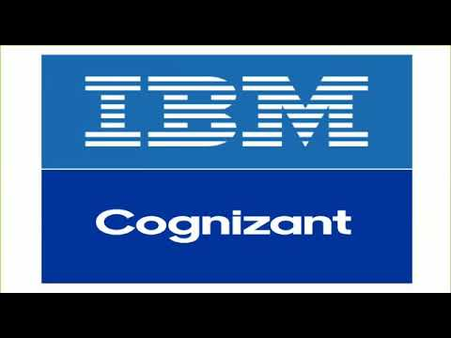](https://www.youtube.com/watch?v=Kl_aKyTz3bo)

## The Idea

COVID-19 has citizens looking for answers about symptoms and testing sites as well as current status of schools, transportation, and other public services. Using Watson Assistant designed a virtual assistant pre-loaded to understand and respond to common questions about COVID-19, scan COVID-19 news articles using Watson Discovery and respond to COVID statistics inquires with data from trusted sources.

Next integrate the chatbot in an IBM Cloud hosted web server, using a Slack integration or Mobile integration using android studio( with speech to text & text to speech IBM cloud service feature)

## How do Chatbots work

Now let us understand how a chatbot works with the **Architecture Diagram** below:

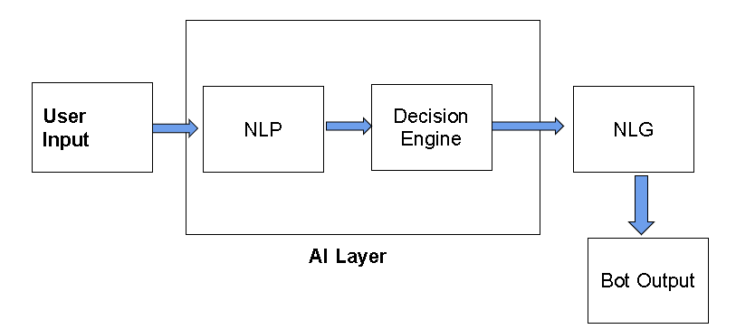

In the very first step, user input is given to the **AI layer**, which has an **NLP**unit and a **Decision Engine.**

**The NLP (Natural Language Processing) unit** understands user intent & context i.e. what exactly the user is asking for and based on that it converts user input into machine understandable language and processes it to a decision engine.

**Decision Engine** Based on the NLP output **Decision Engine**uses machine-learning algorithms to decide the bot response and process that response to the NLG unit

**NLG (Natural Language Generation) unit**as the name suggest converts Machine Language into a plain text or human-understandable language.

Finally, the output of the NLG unit is our Chatbot response, which is processed to the user.

## Architecture

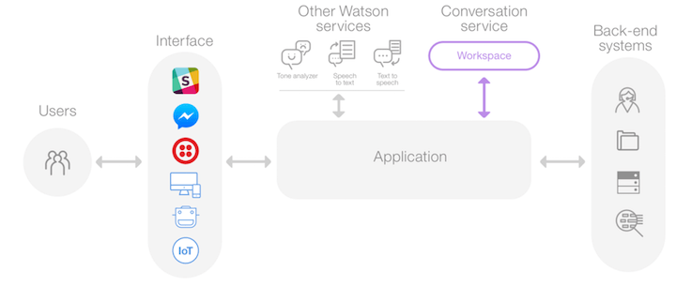

**Website integration with COVID-19 crisis communication chatbot**

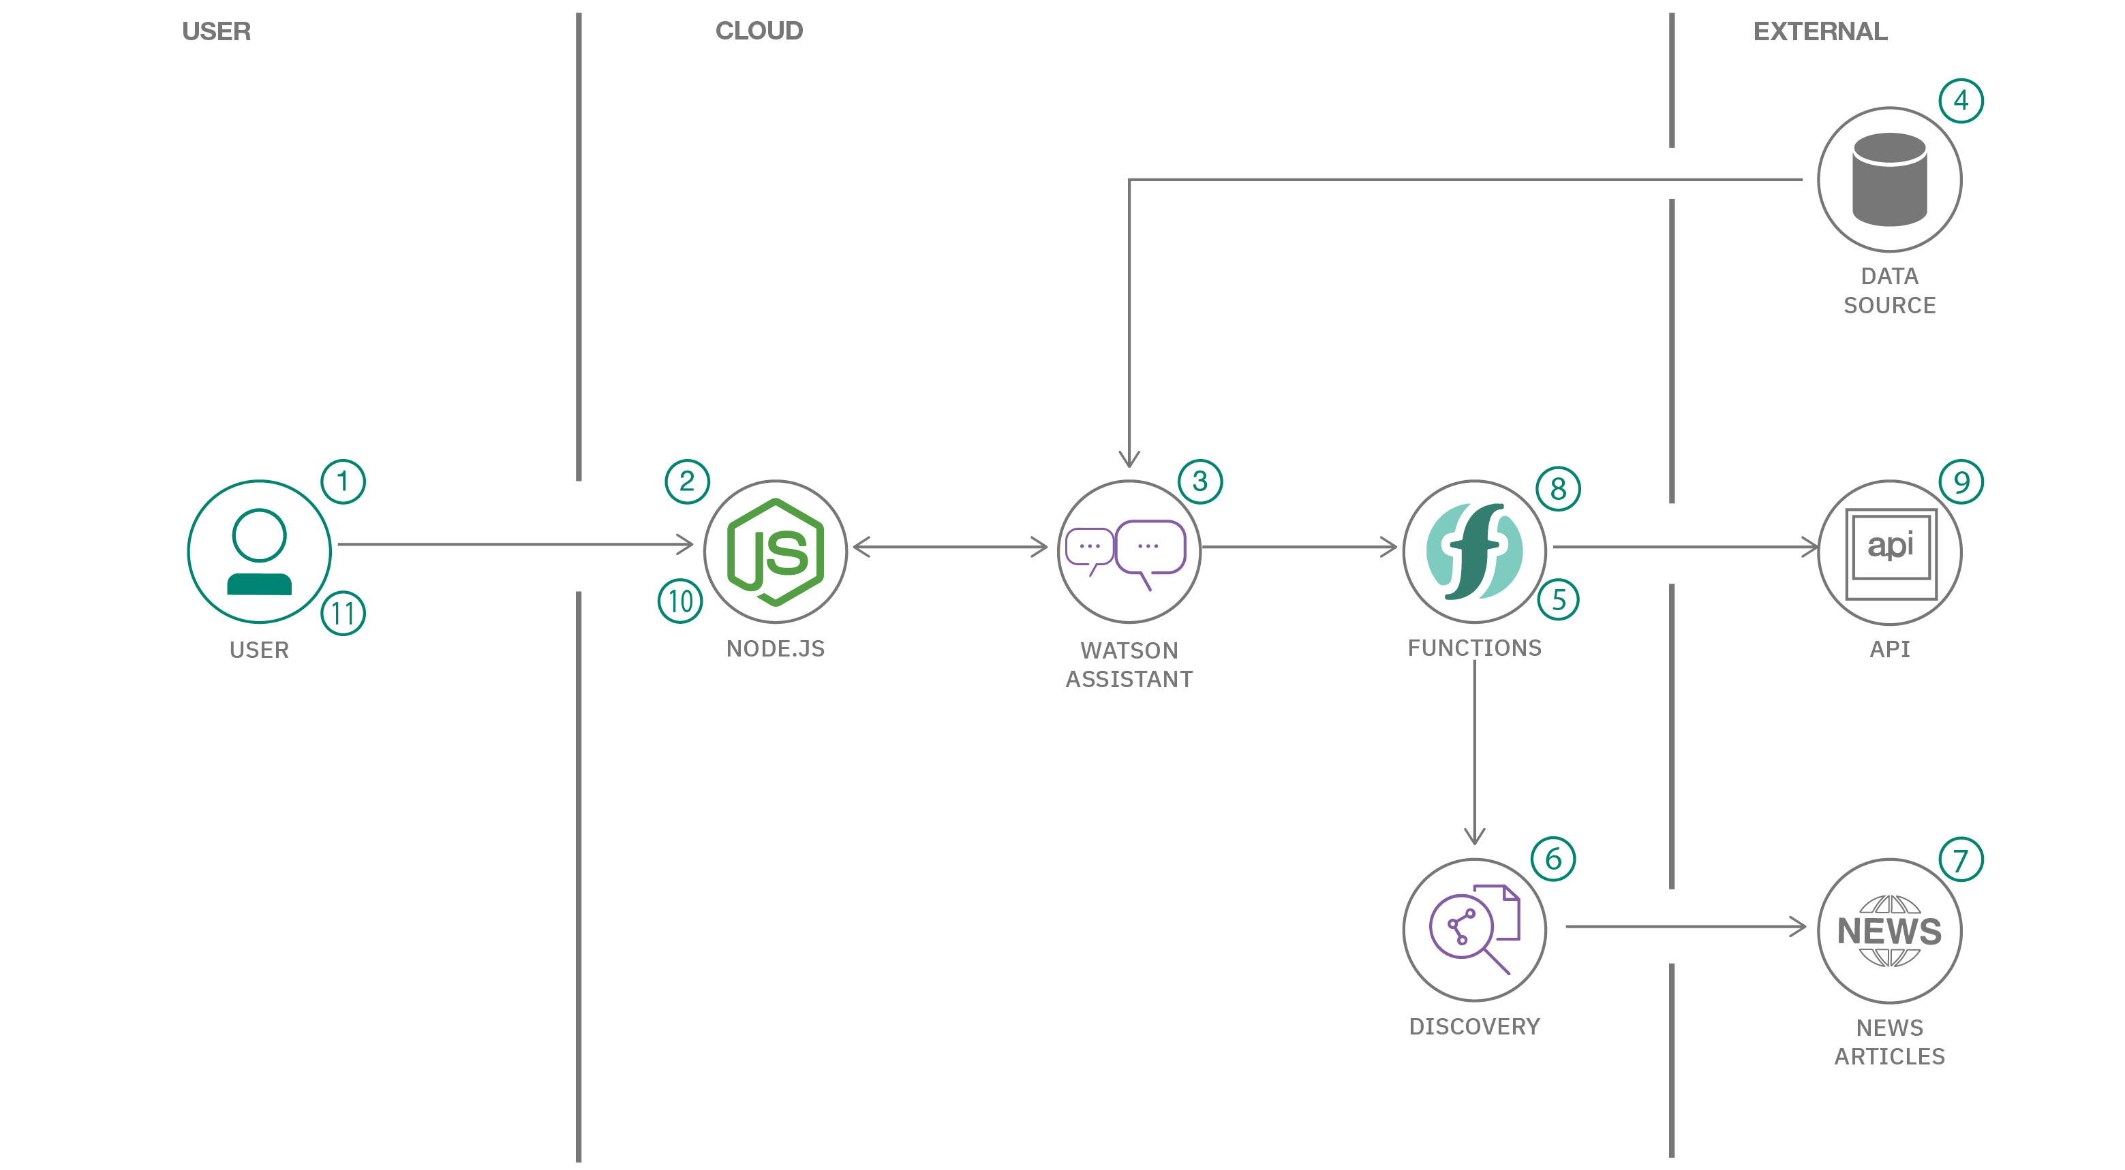

1. User visits a website with the COVID-19 chatbot and asks a question.
2. Node.js web server calls the Watson Assistant service hosted in IBM Cloud.
3. Watson Assistant uses natural language understanding and machine learning to extract entities and intents of the user question.
4. Source COVID-19 FAQ information from trusted CDC data.
5. Watson Assistant invokes an OpenWhisk open source powered IBM Cloud Function.
6. IBM Cloud Function calls the Watson Discovery service running in IBM Cloud.
7. Watson Discovery scans news articles and responds with relevant articles.
8. Watson Assistant invokes an OpenWhisk open source powered IBM Cloud Function.
9. IBM Cloud Function calls the COVID-19 API to get statistics.
10. Watson Assistant replies to the user inquiry.
11. Node.js web server displays the chat answer to the user.

**Slack integration with COVID-19 crisis communication chatbot**

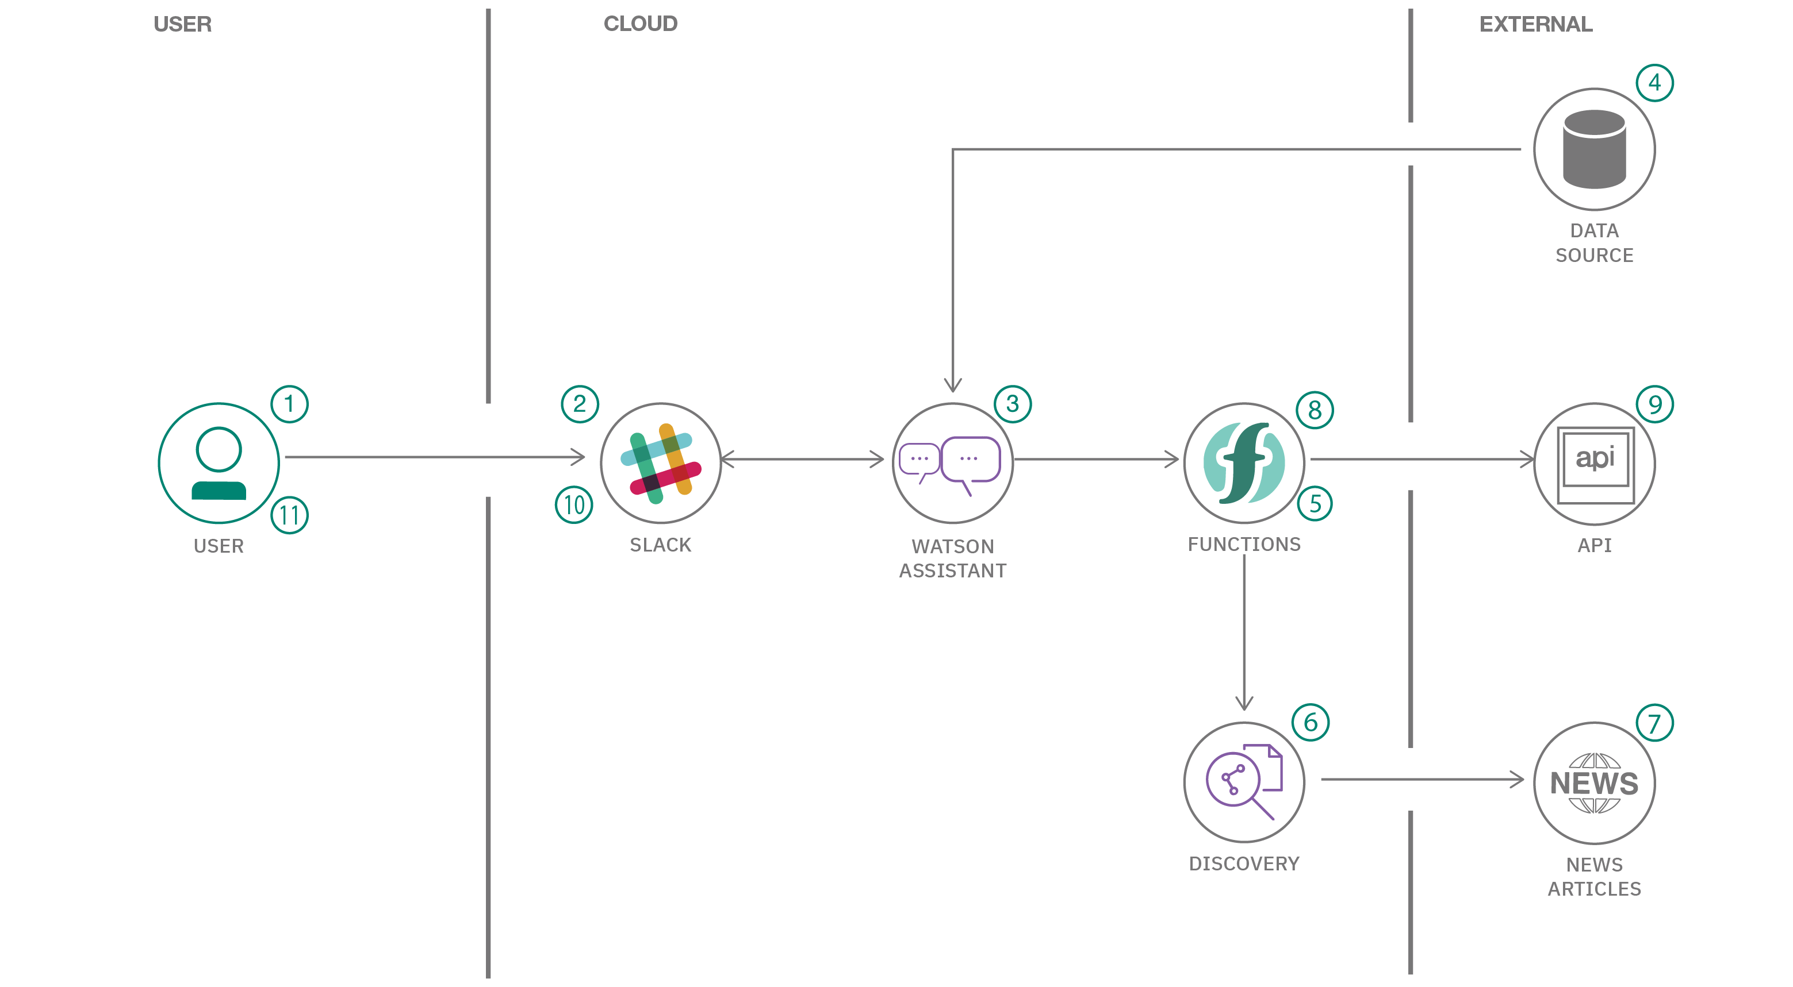

1. **User invokes a COVID-19 Slack integration chatbot app and asks a question**.
2. Slack app calls the Watson Assistant service hosted in IBM Cloud.
3. Watson Assistant uses natural language understanding and machine learning to extract entities and intents of the user question.
4. Source COVID-19 FAQ information from trusted CDC data
5. Watson Assistant invokes an OpenWhisk open source powered IBM Cloud Function.
6. IBM Cloud Function calls the Watson Discovery service running in IBM Cloud.
7. Watson Discovery scans news articles and responds with relevant articles.
8. Watson Assistant invokes an OpenWhisk open source powered IBM Cloud Function.
9. IBM Cloud Function calls the COVID-19 API to get statistics.
10. Watson Assistant replies to the Slack application.
11. Slack app displays the chat answer to the user.

**Andoid integration with COVID-19 crisis communication chatbot**

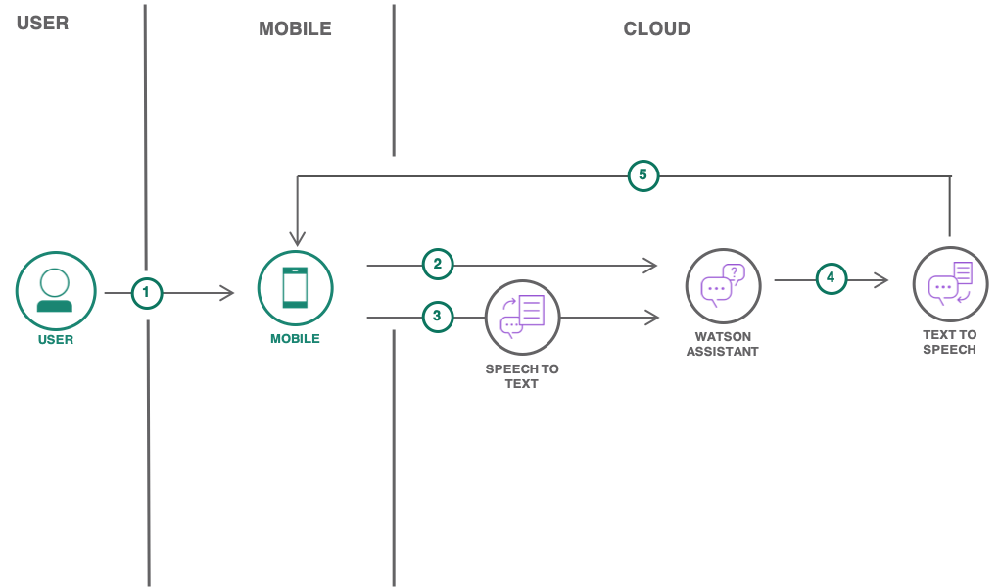

1. User launches the mobile application on an Android device.
2. User sends a text message to IBM Watson™ Assistant.
3. User sends a voice input. The audio is transcribed to text with IBM Watson™ Speech to Text. The text is then passed to IBM Watson™ Assistant.
4. The reply from IBM Watson™ Assistant is converted to audio by IBM Watson™ Text to Speech
5. The response from IBM Watson™ Assistant is sent back to the mobile application.

## Roadmap

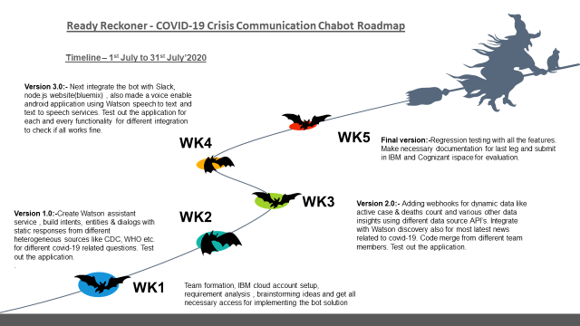

## Technology

**IBM technology**

* [IBM Watson Assistant](https://www.ibm.com/cloud/watson-assistant/)
* [Watson Discovery](https://www.ibm.com/cloud/watson-discovery)
* [Watson Speech to Text](https://www.ibm.com/cloud/watson-speech-to-text)
* [Watson Text to Speech](https://www.ibm.com/cloud/watson-text-to-speech)
* [IBM Cloud Functions](https://cloud.ibm.com/functions/)

**Open source technology**

* [Node.js](https://nodejs.org/en/)
* [Apache OpenWhisk](https://openwhisk.apache.org/)
* Android Studio

## Getting started

**Prerequisite**

* Register for an [IBM Cloud](https://www.ibm.com/account/reg/us-en/signup?formid=urx-42793&eventid=cfc-2020?cm_mmc=OSocial_Blog-_-Audience+Developer_Developer+Conversation-_-WW_WW-_-cfc-2020-ghub-starterkit-communication_ov75914&cm_mmca1=000039JL&cm_mmca2=10008917) account.
* Install Android Studio

**Solution Implementation**

Follow the below steps to build the solution

1. Go to [www.cloud.ibm.com](http://www.cloud.ibm.com/) and login to IBM Cloud

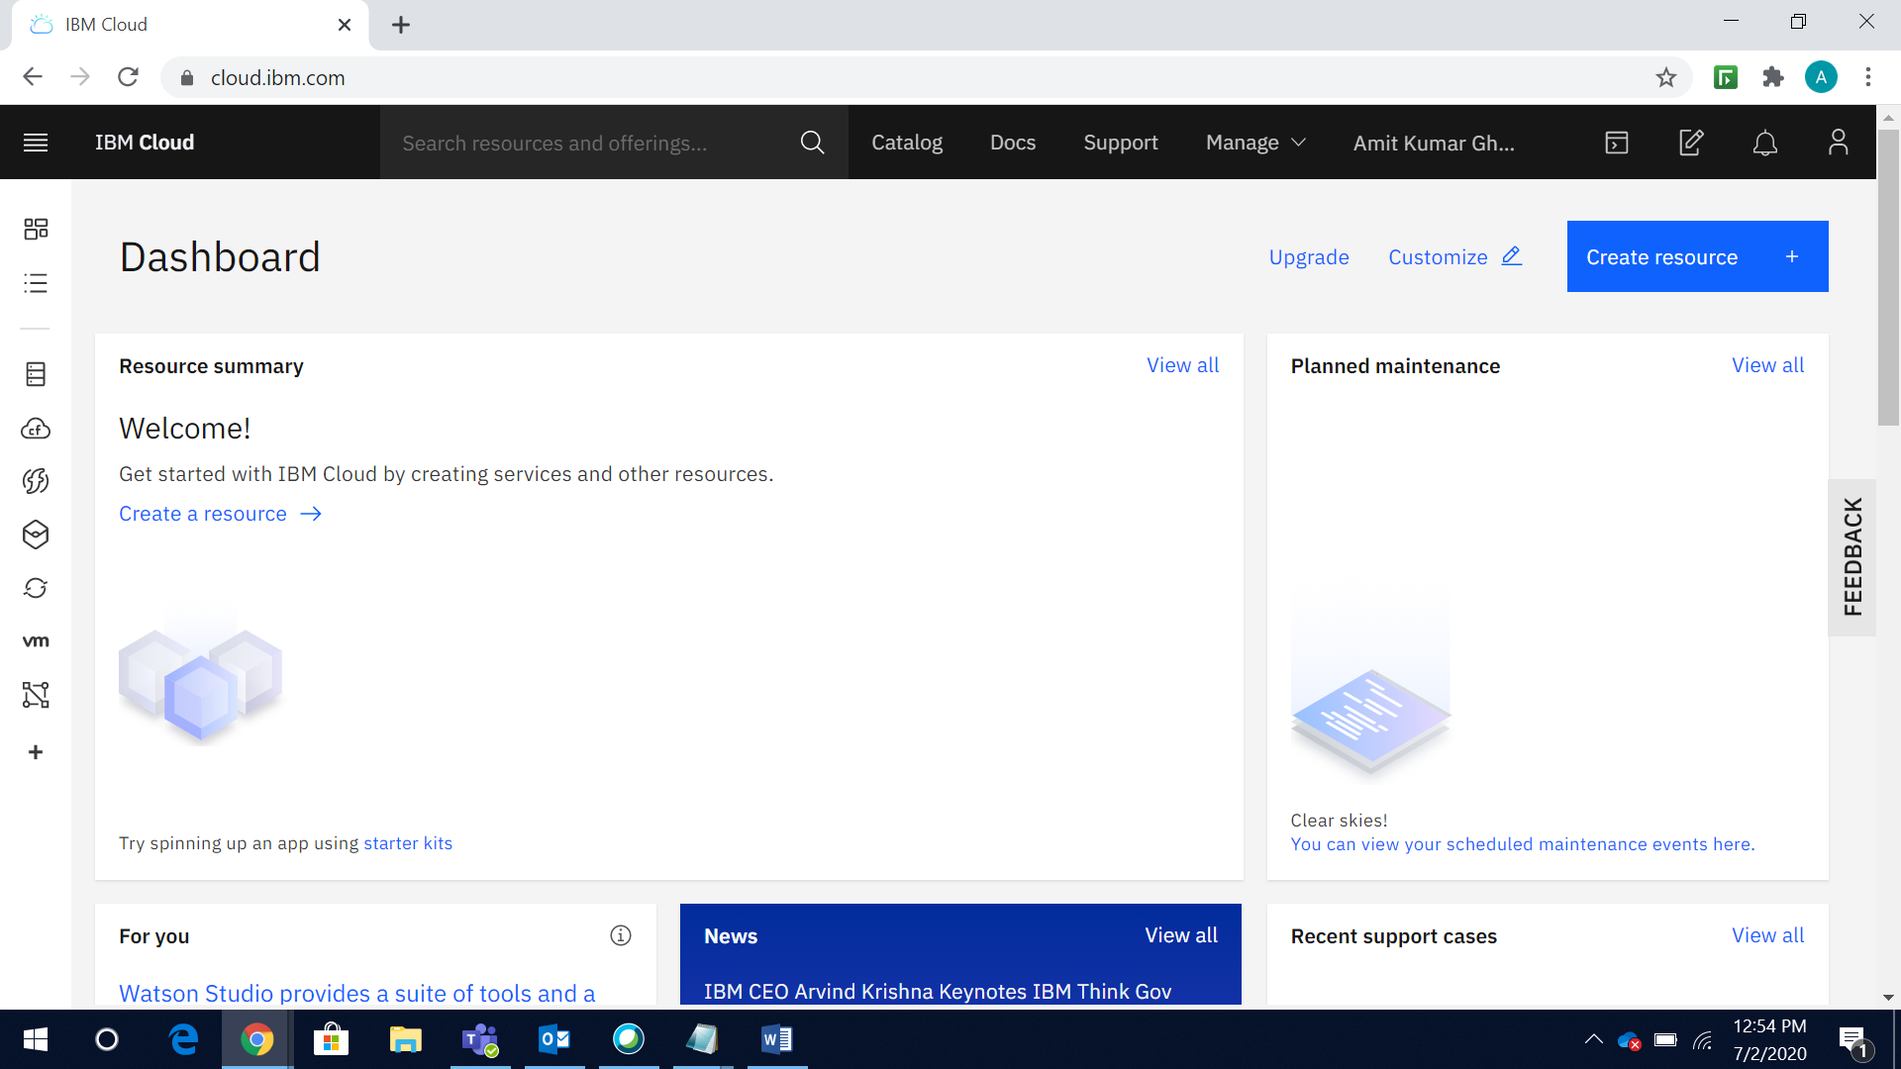

1. Go to **Catalog** and Select **Services**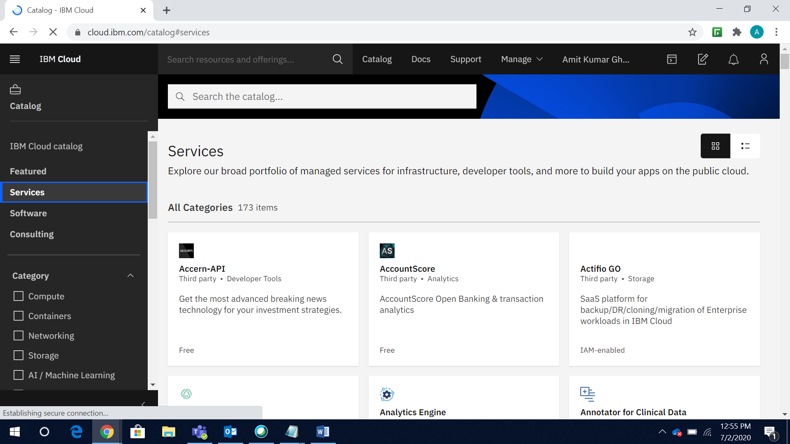



1. Select **AI / Machine Learning** and click **Watson Assistant**

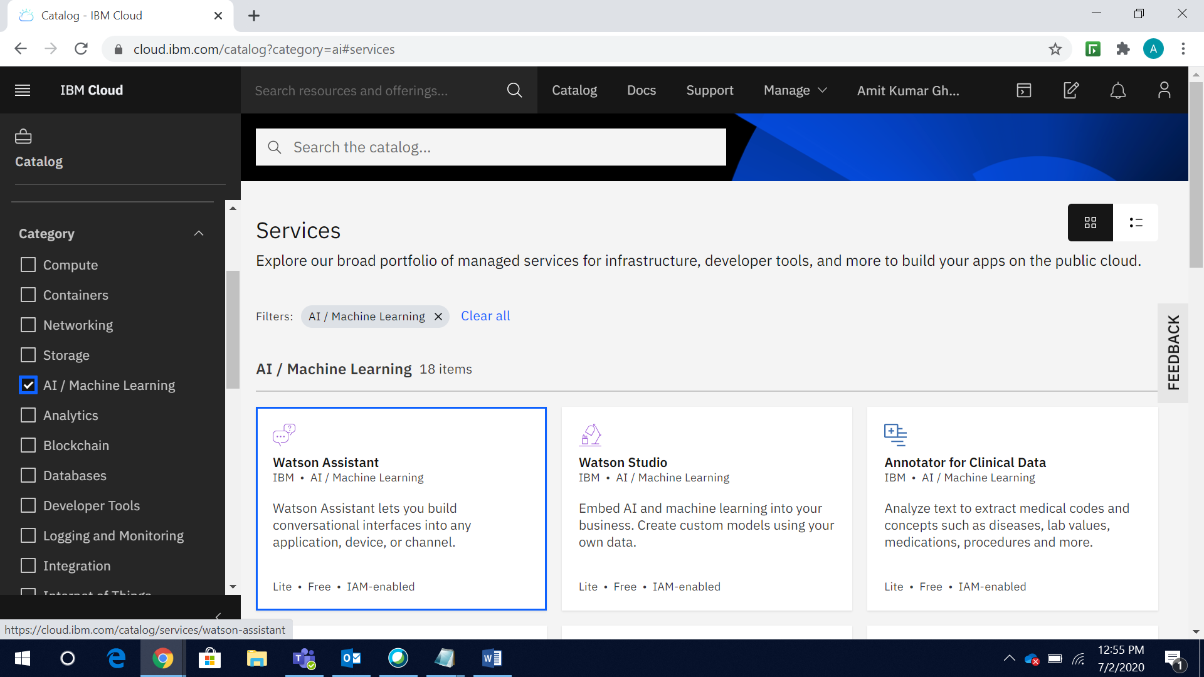

1. Give a **Service name** and click **Create**

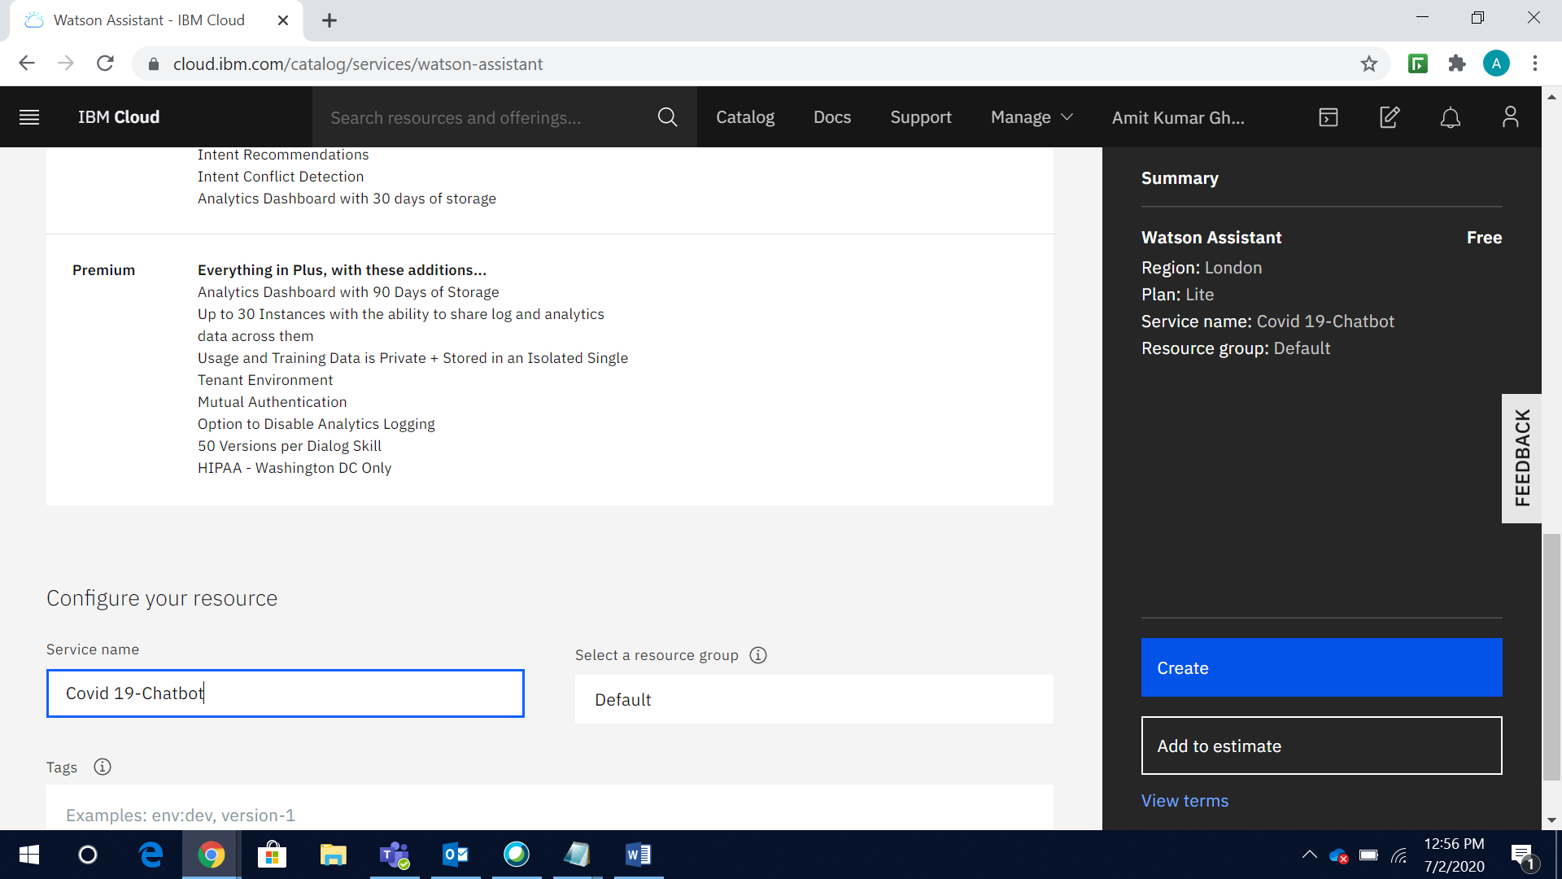

1. Launch the **Watson Assistant service**

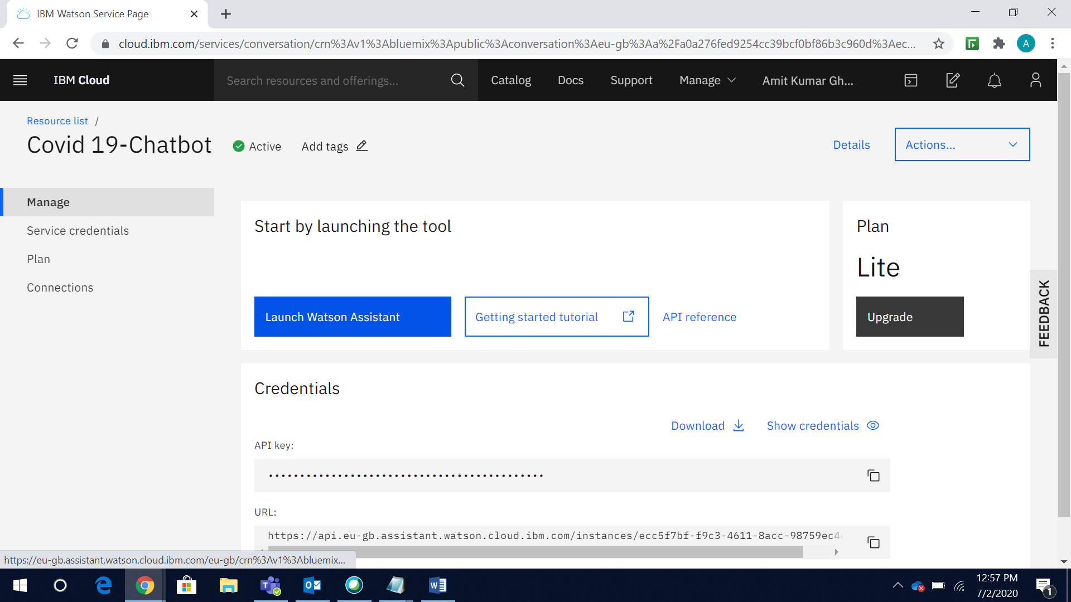

1. Click on **Skills** to add skills to the assistant

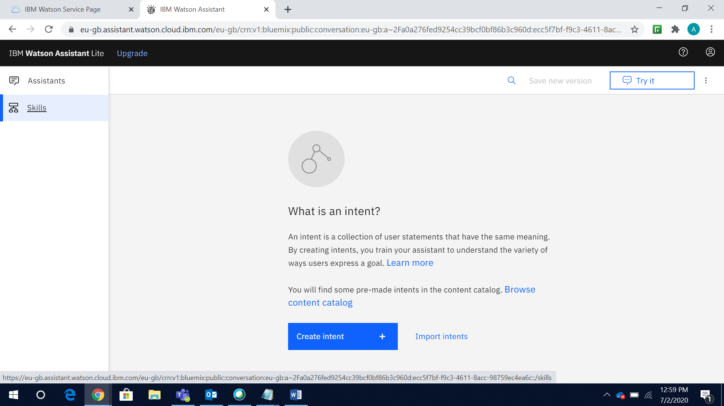

1. Click on **Create Skill**

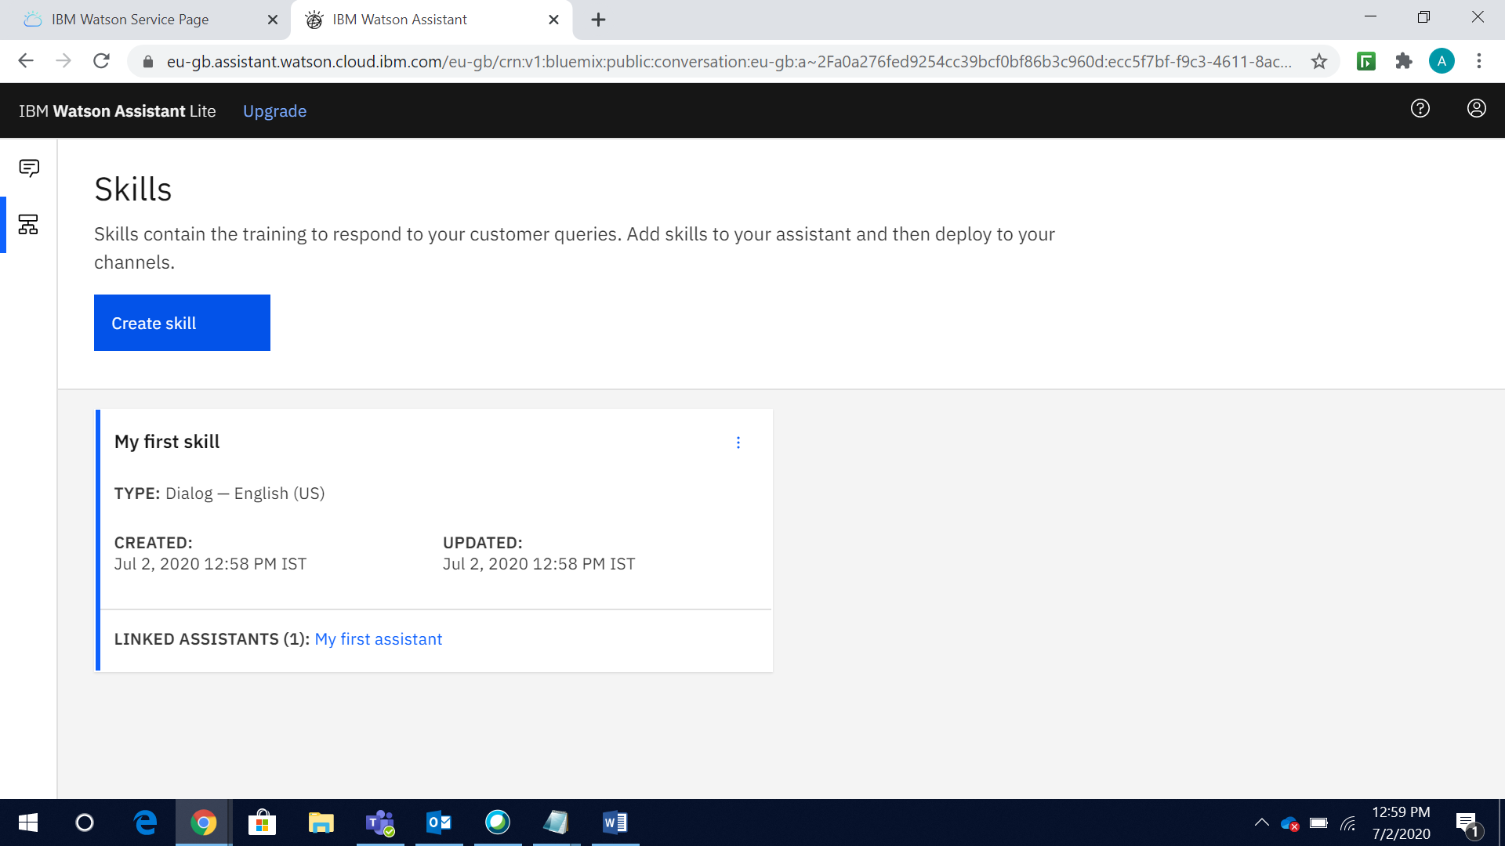

1. Click **Next**

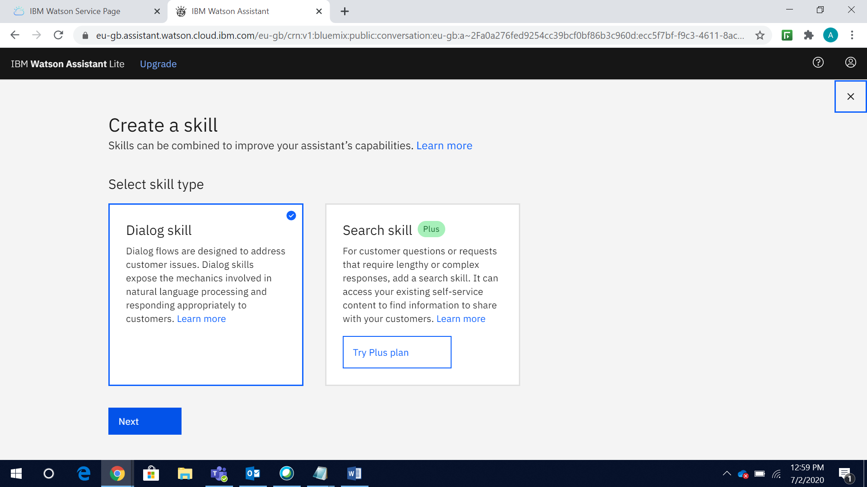

1. Click **Import Skill > Choose JSON file** and import the**. Json file** created with intents, entities and dialogs. Attached our Json file.



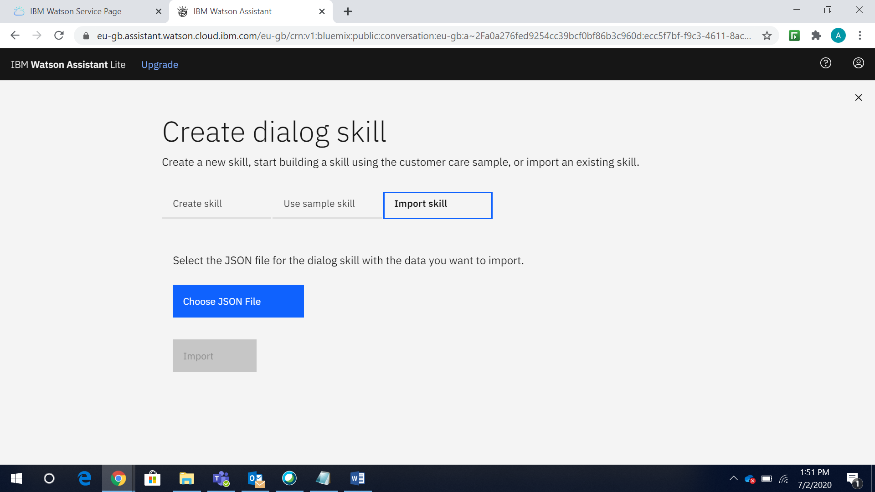

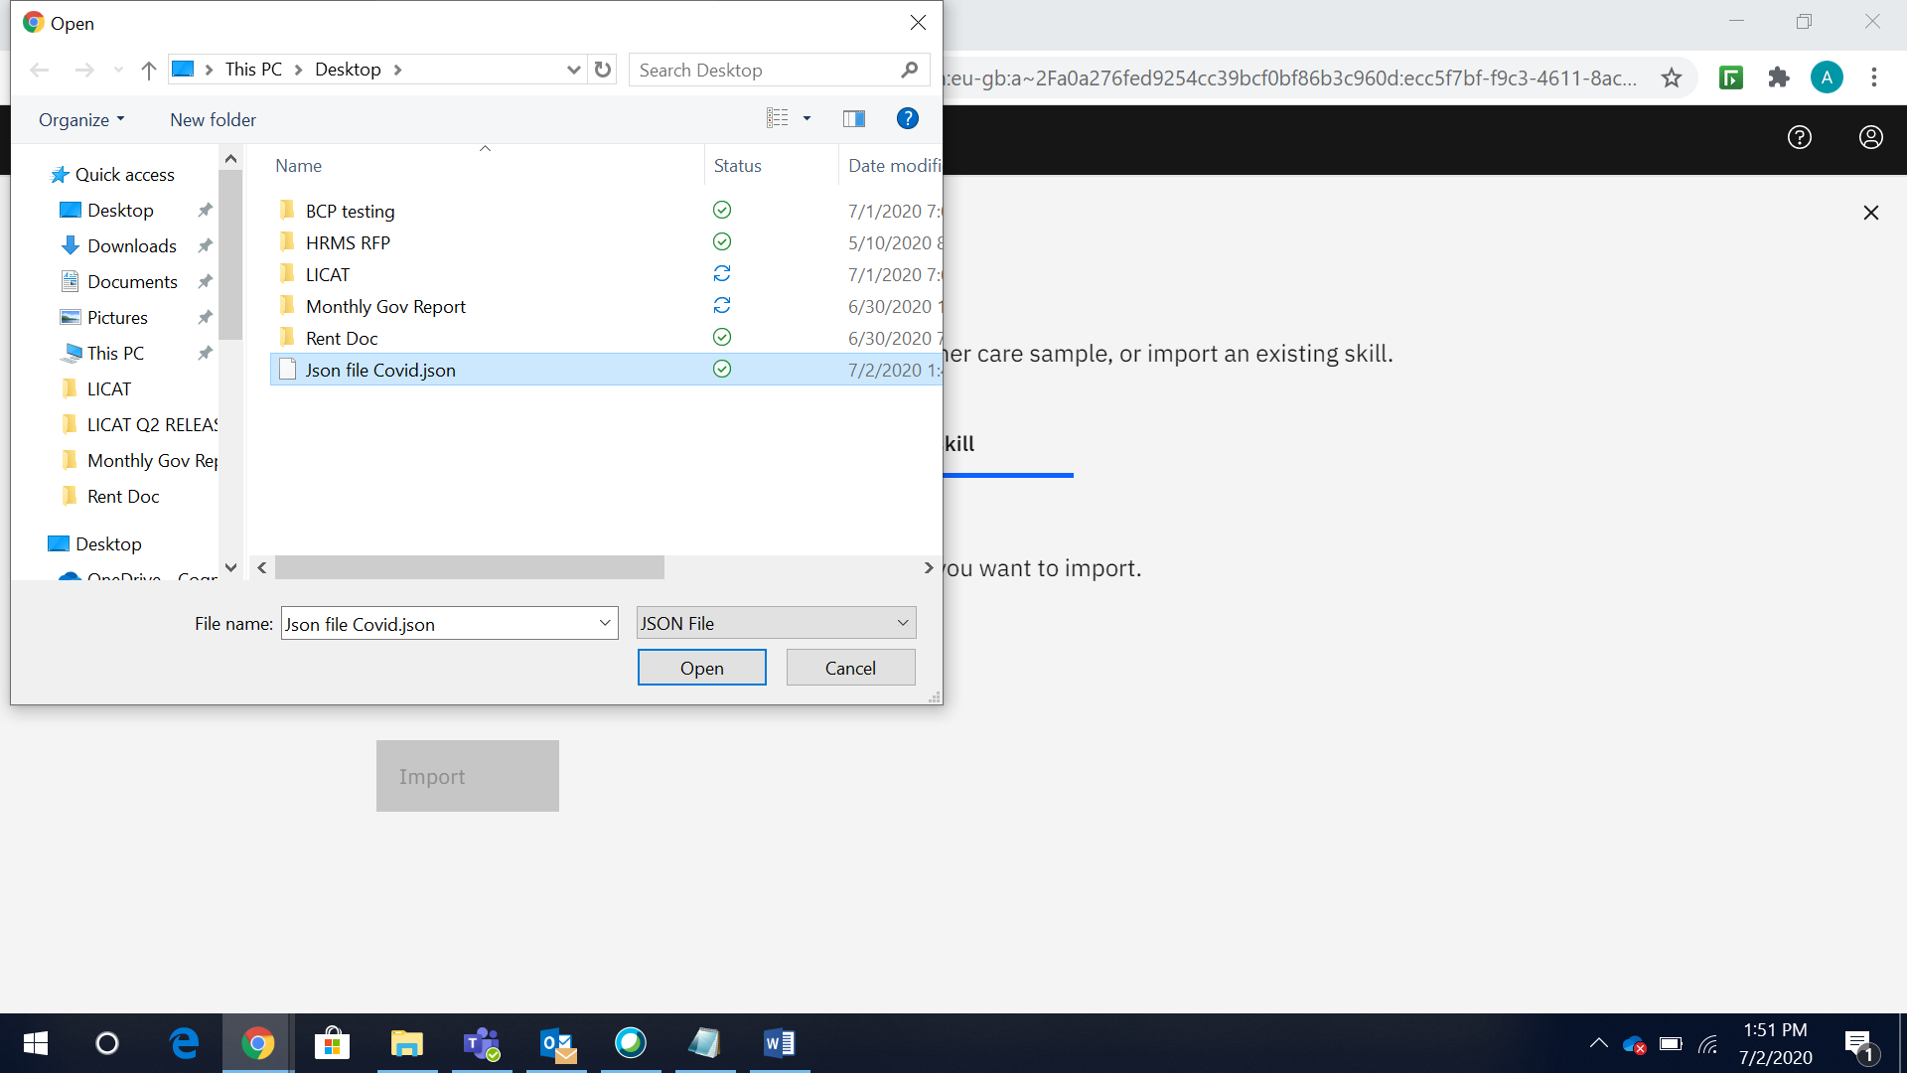

1. You will get all **Intents, Entities, Dialogs** loaded created as per JSON file

***Intents:***

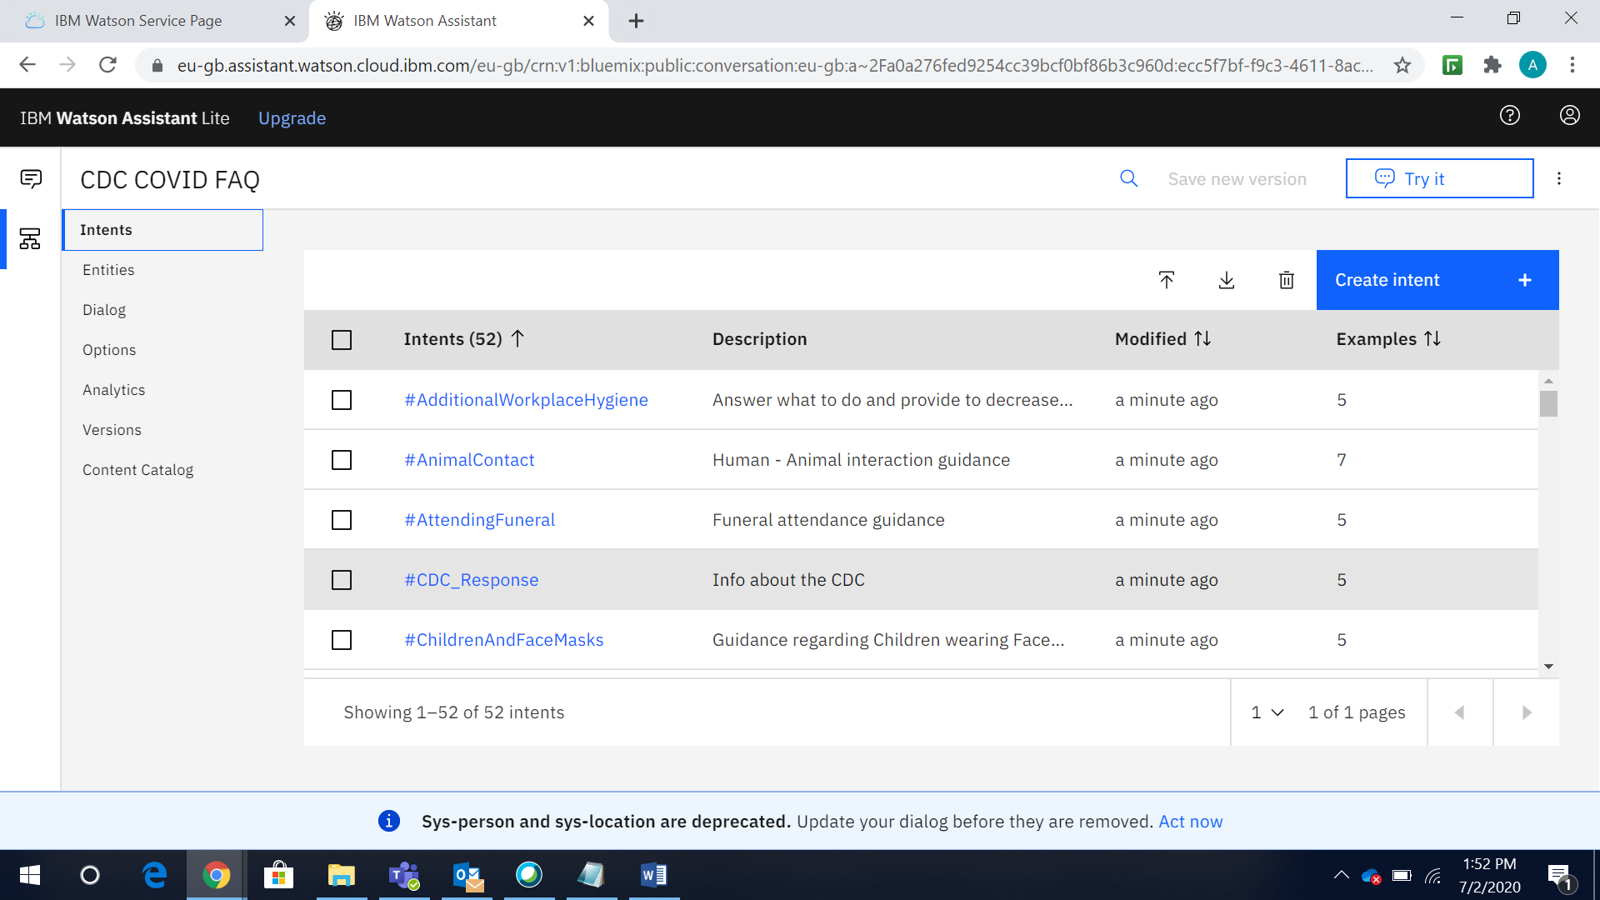

***Entities:***

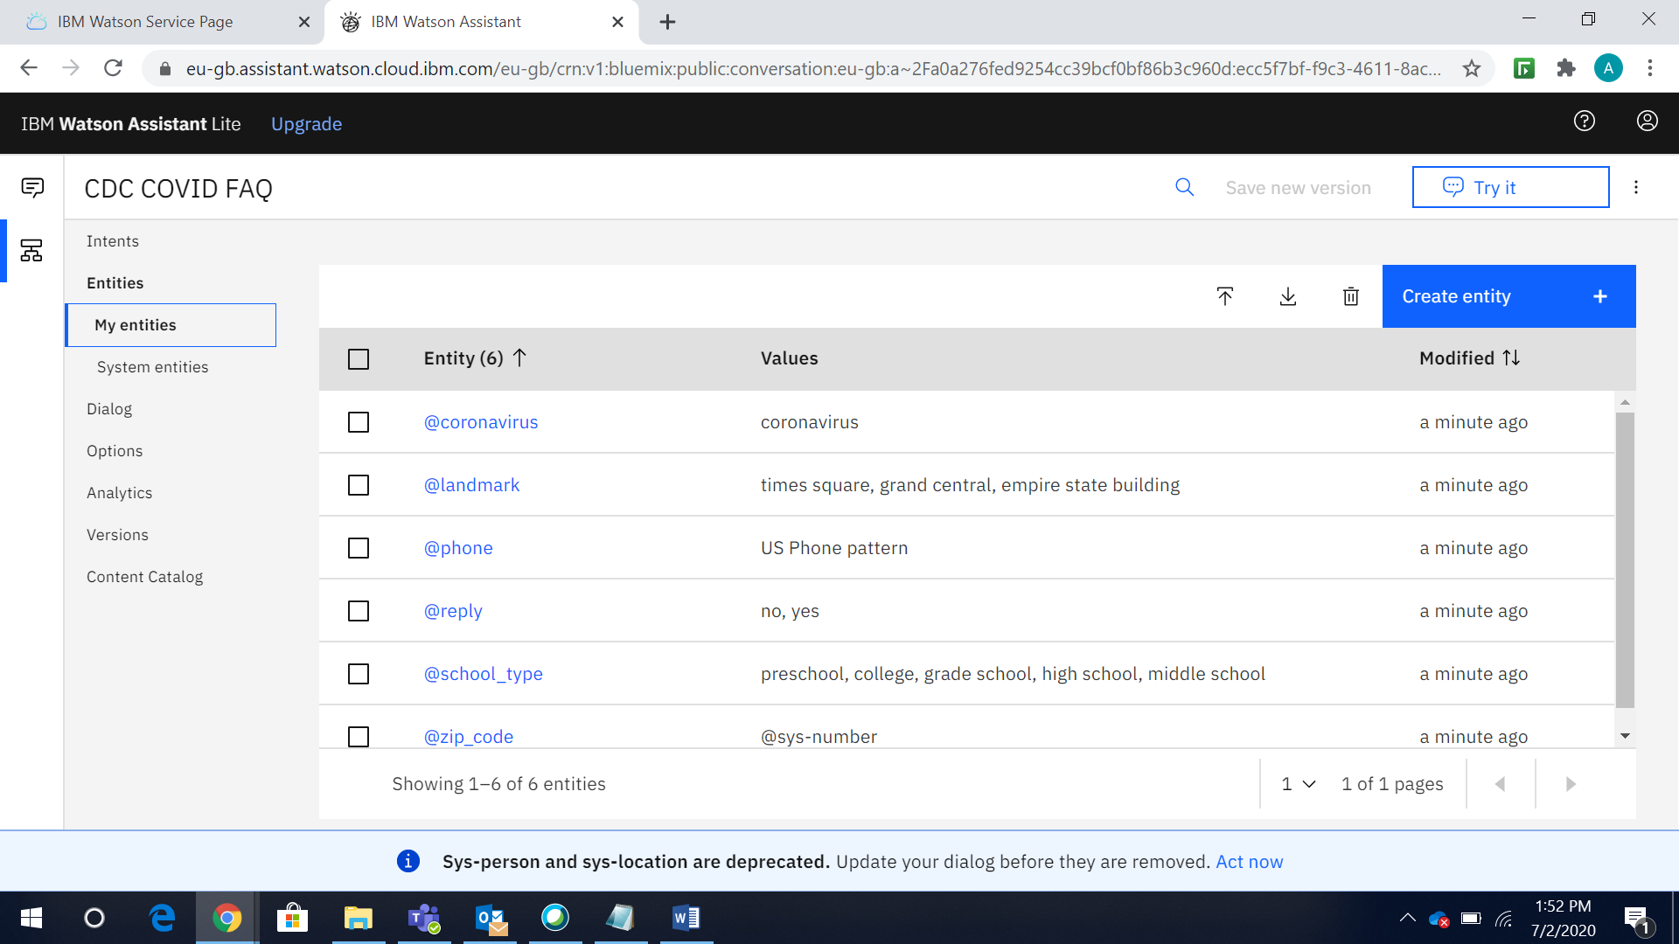

***Dialogs:***

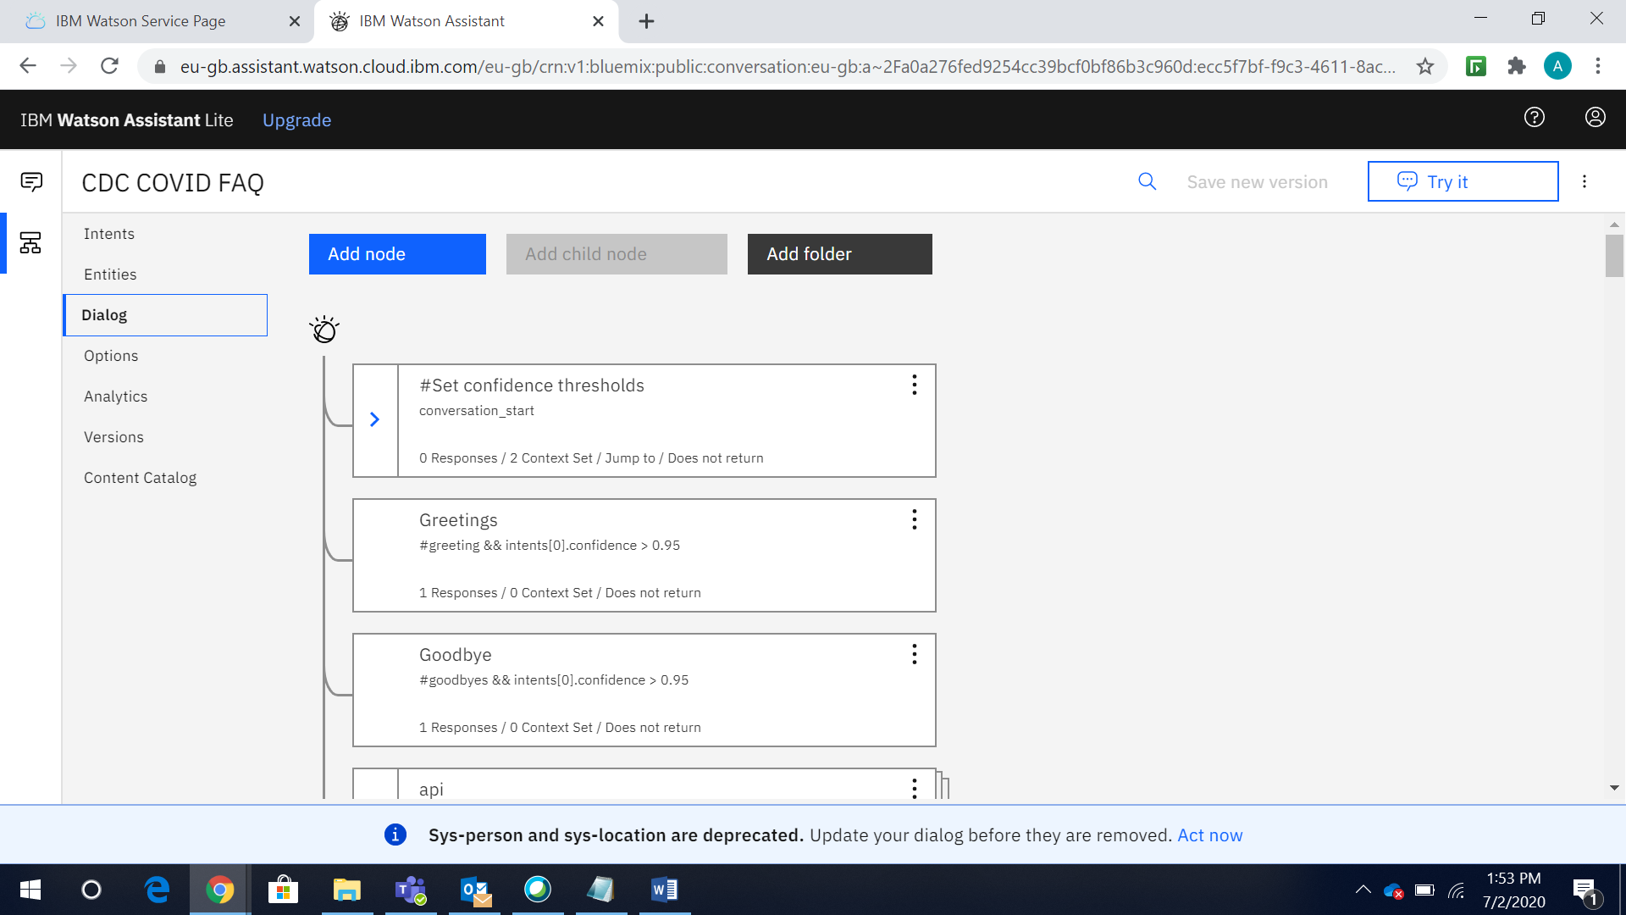

1. Alternatively, we can add/modify/delete any intents, entities, dialogs etc., directly in Watson Assistant and same we can export to a .Json format. Then again we can add/modify/delete any intents, entities, dialogs etc. in .Json file and upload it via Skill Import i.e. vice-versa we can do it. If we want to modify any intents or entities or dialogs we can do it follow the below steps.

Let’s say I am modifying the below #greeting intents with adding one more example as “Hi Watson”.

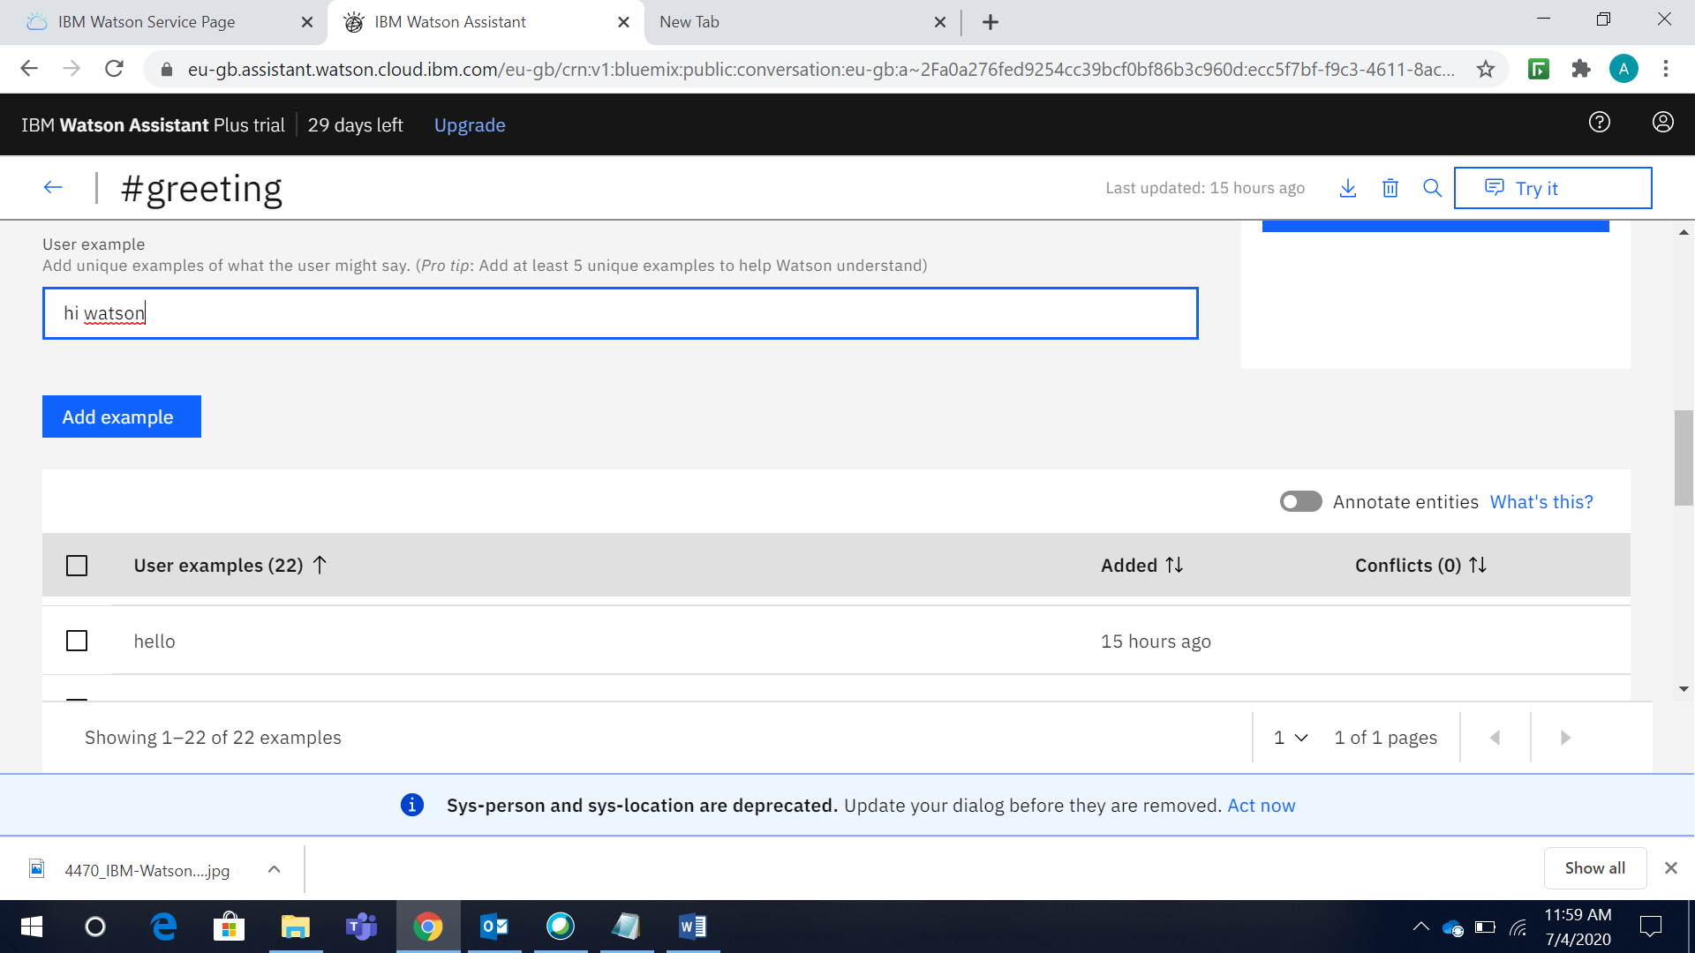

Let’s check it instantly by clicking on Try it. See it’s working. Similarly we can do it for entities and dialogs also.

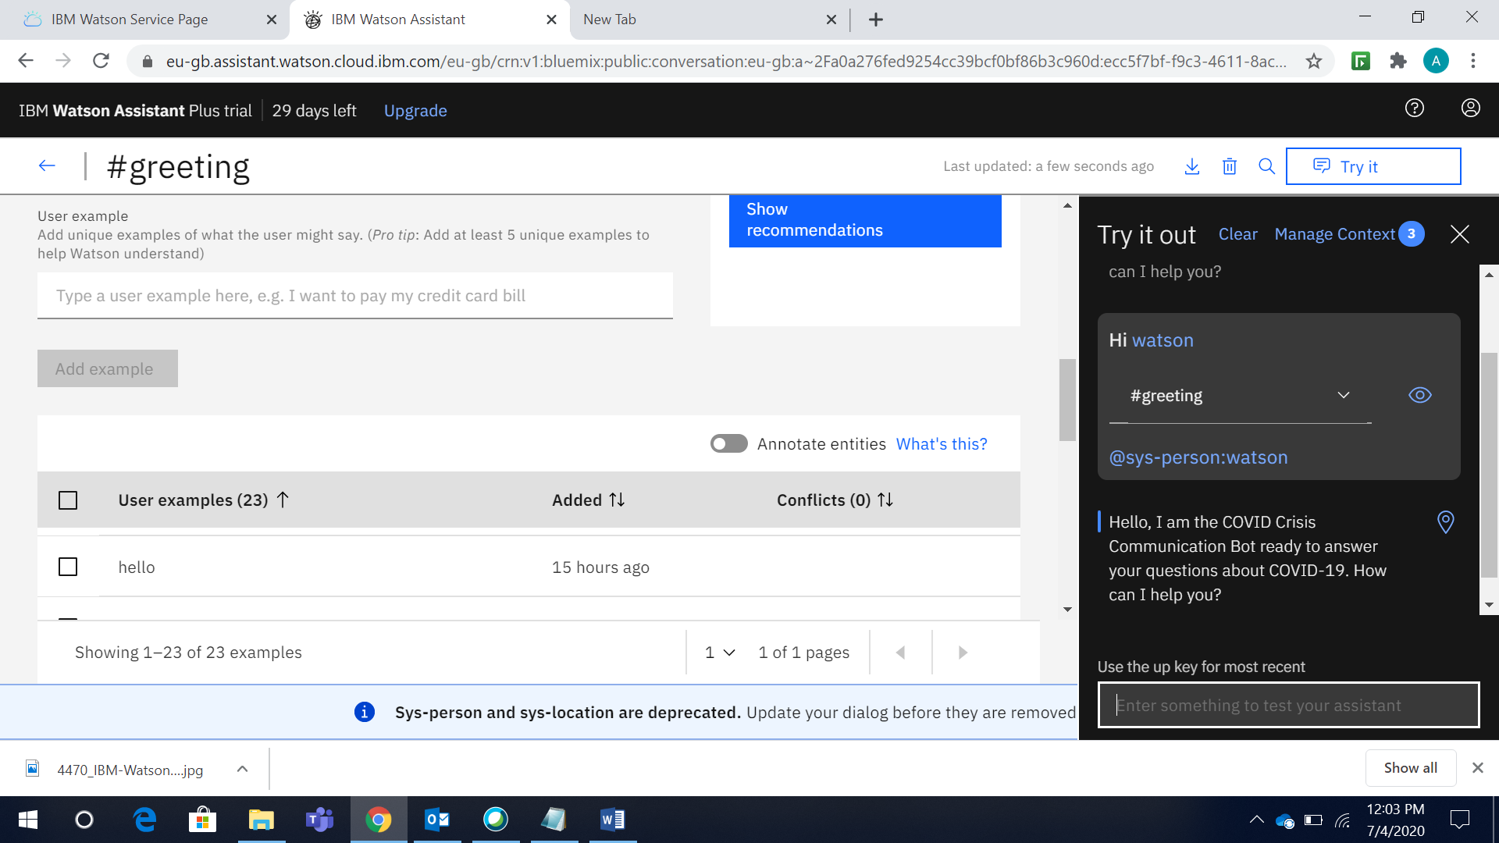

1. Go back to your **Dialog Skills** and click on the **Add Integration**

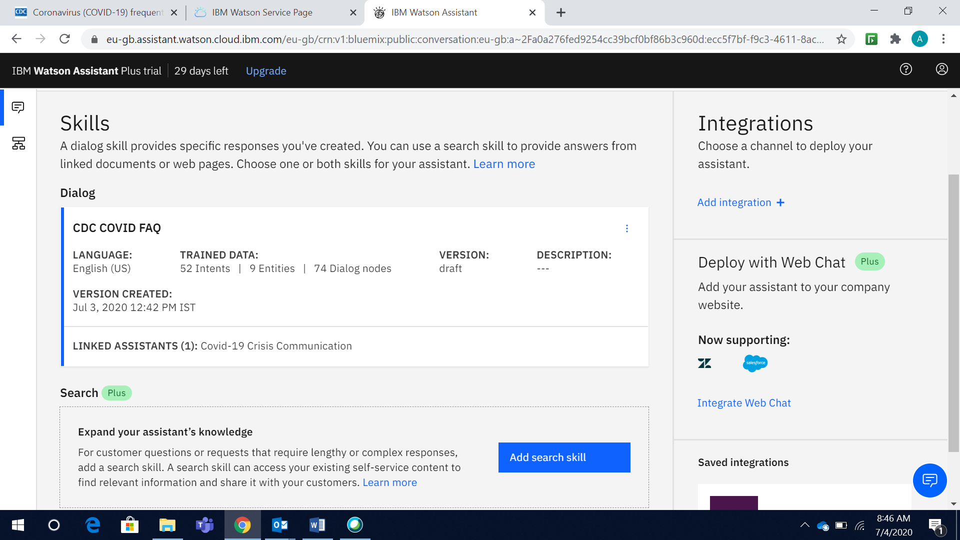

1. Select **Preview link**

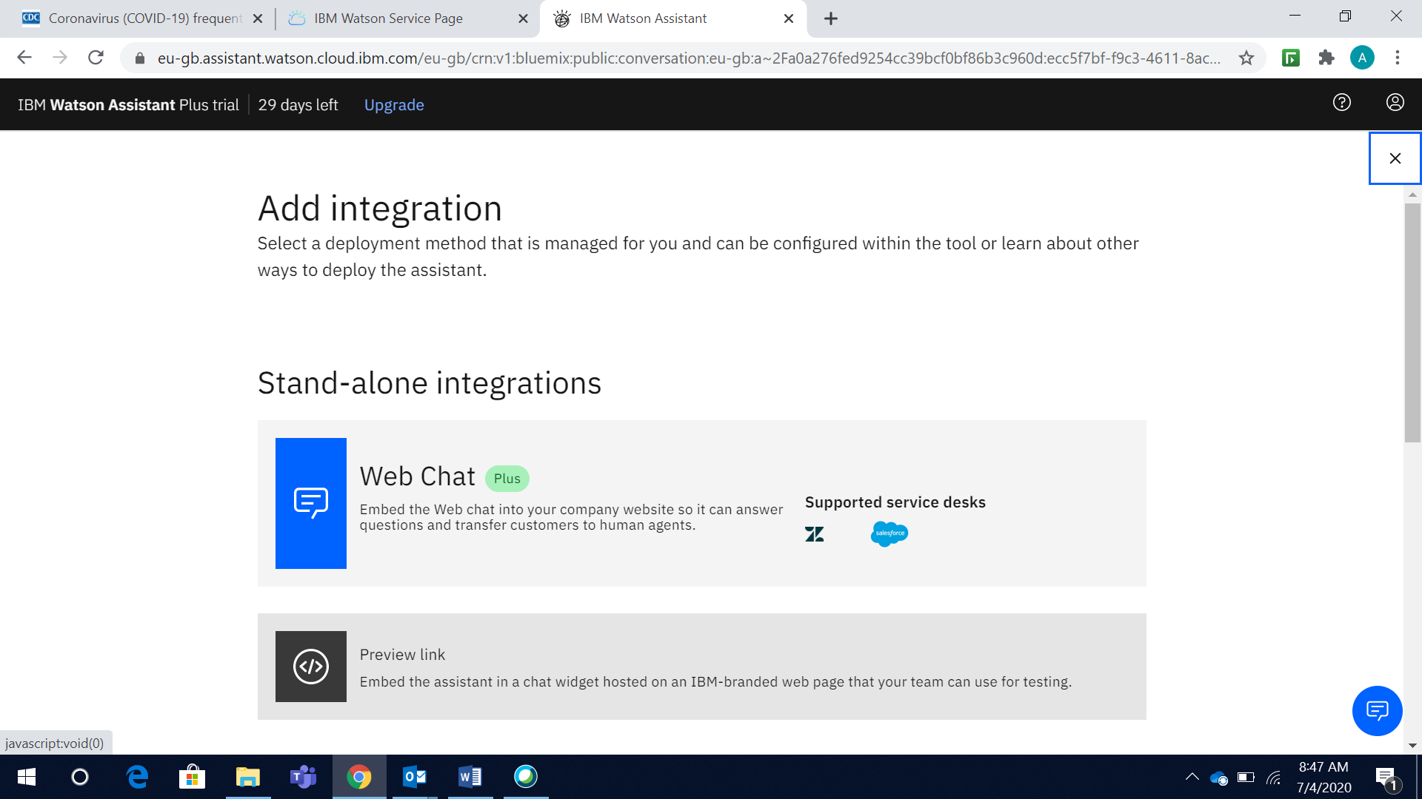

1. Click **Create**

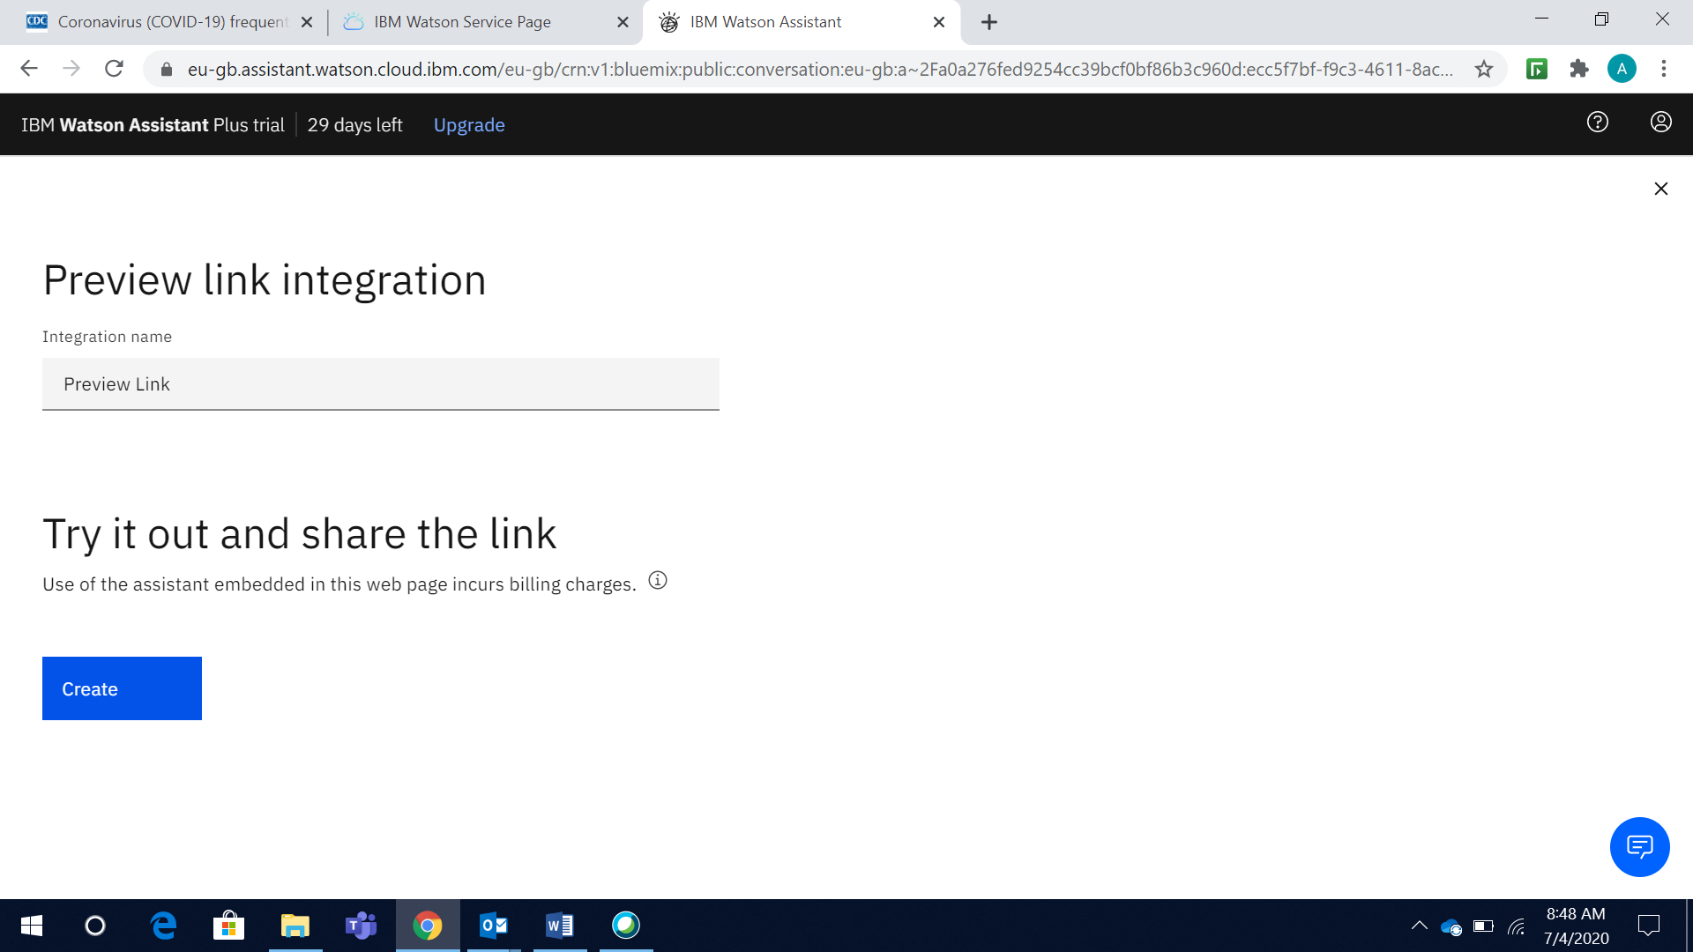

1. Link has been generated. Click on that link

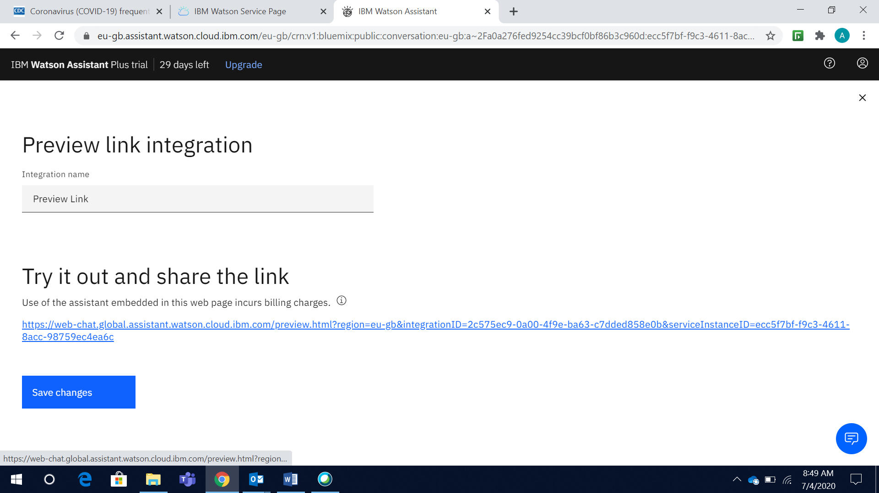

1. Now we are all set. Ask the Watson Assistant chatbot some questions about COVID-19.Chatbot has been giving responses to the queries asked about covid-19

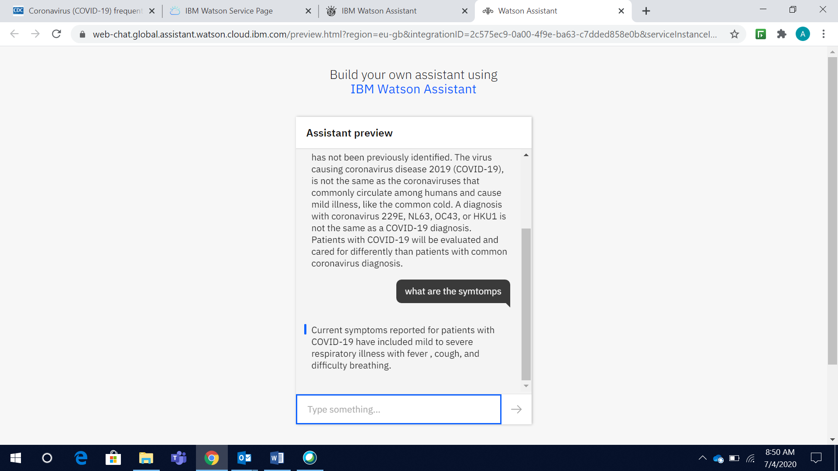

## Take on Covid-19 with the Next Steps

Now you have created Watson Assistant-enabled chatbot, you need to connect it to various data source. With Watson Assistant, you need to do this via a webhook. Integrate this chatbot with Slack, embed with a node.js website, or build a voice enabled mobile application.

**Connect your Chabot to data sources via a webhook ( Watson Discover and other data source API’s)**

A webhook is a mechanism that allows you to call out to an external program based on something happening in your program. When used in a dialog skill, a webhook is triggered when the assistant processes a node that has a webhook enabled. The webhook collects data that you specify or that you collect from the user during the conversation and save in context variables. It sends the data as part of a HTTP POST request to the URL that you specify as part of your webhook definition. The URL that receives the webhook is the listener. It performs a predefined action using the information that you pass to it as specified in the webhook definition, and can optionally return a response.

We have follow the below link for integration guidance

* <https://developer.ibm.com/technologies/artificial-intelligence/tutorials/crisis-communication-chatbot-watson-assistant-webhook-integration-discovery-covid-data/>

Here is our outcome

In the below code section paste out attached code rest all steps follow as per above link



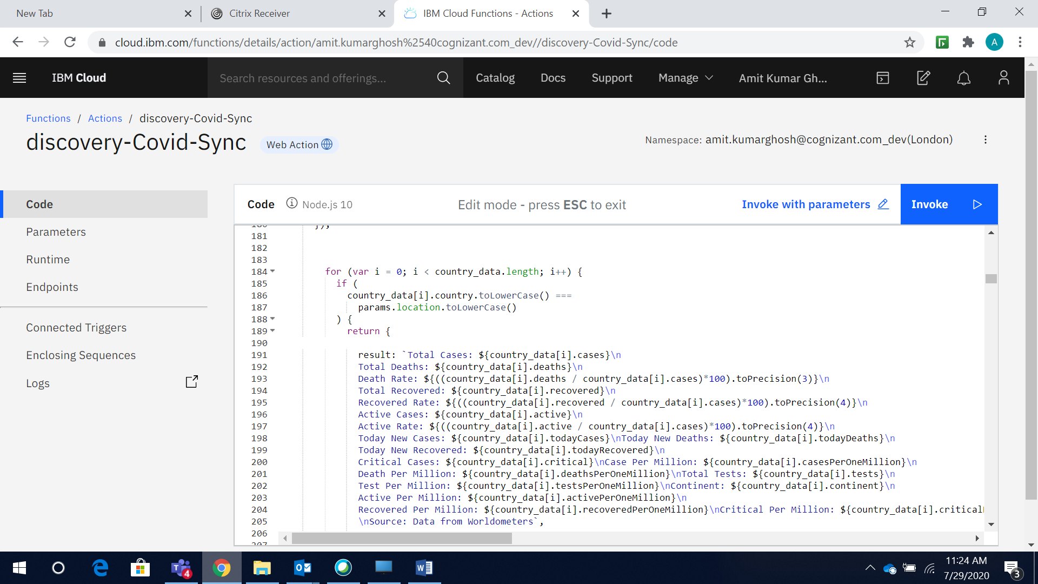

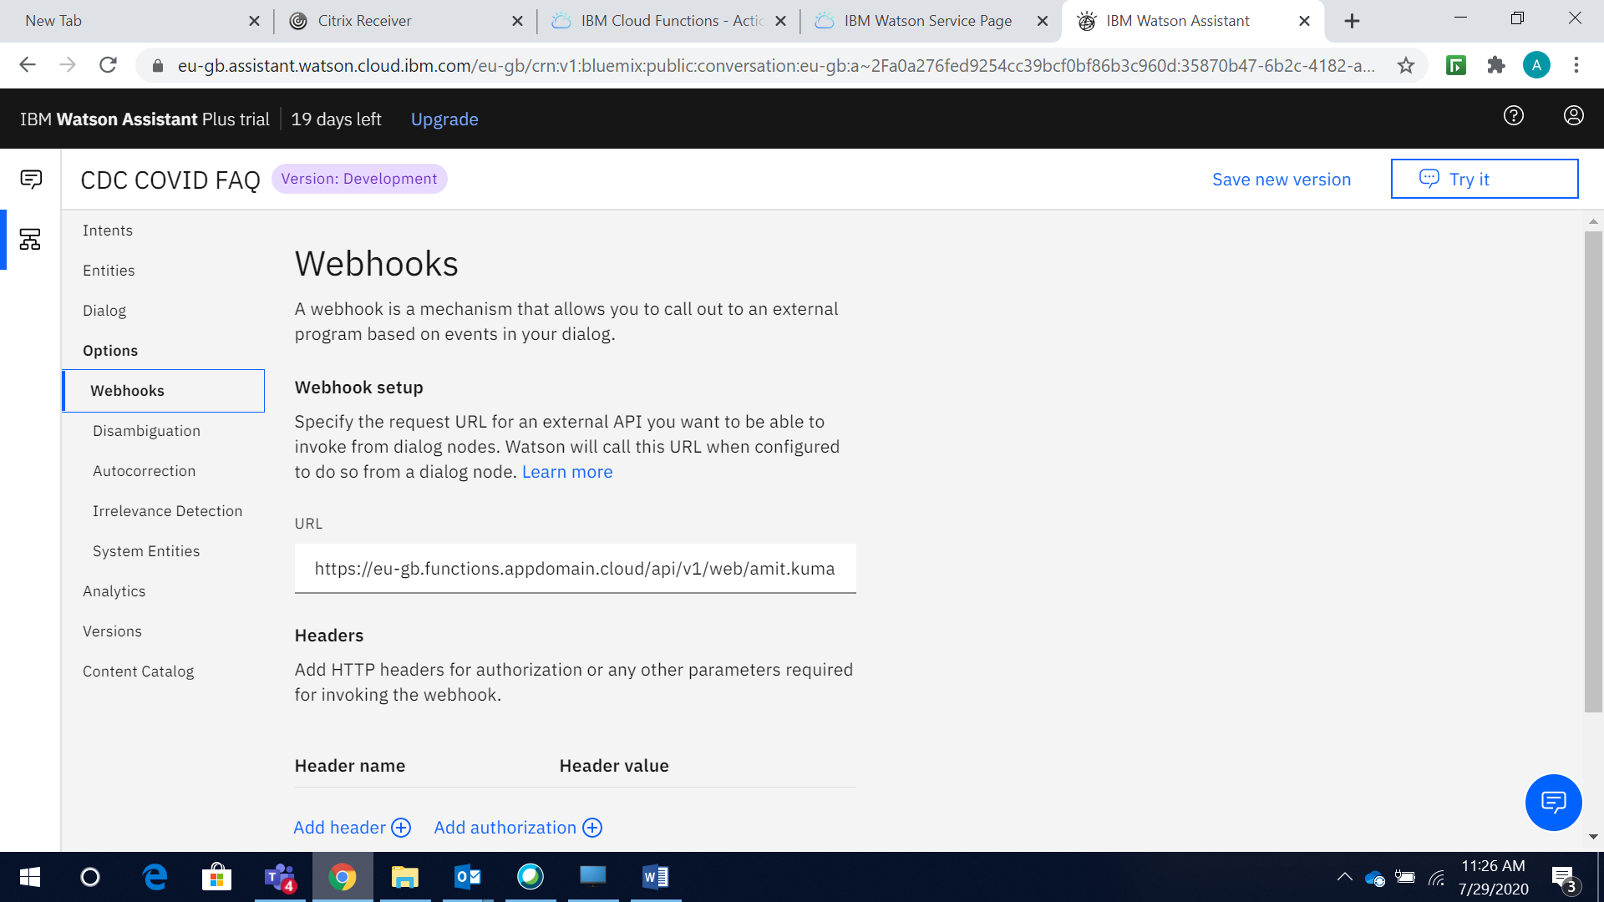

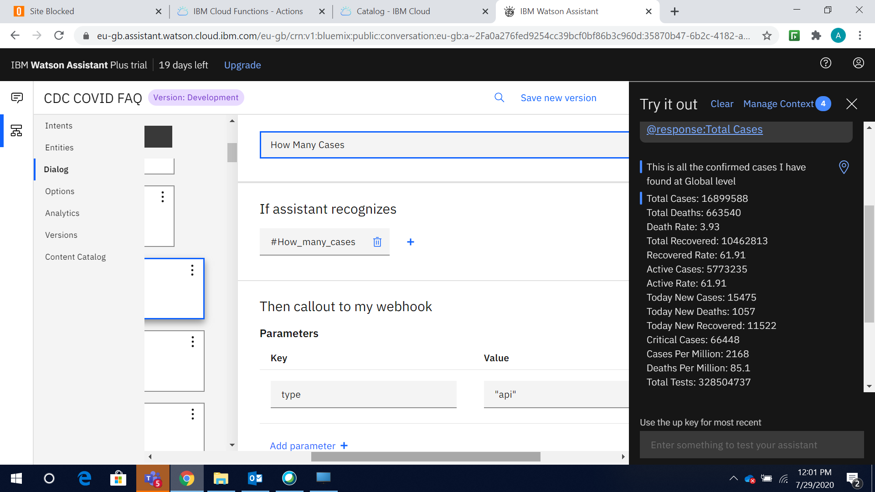

**Integrate your COVID-19 Chabot with Slack**

Now let’s deploy it to Slack. Slack is a cloud-based messaging application that helps people collaborate with one another. After you configure a dialog skill and add it to an assistant, you can integrate the assistant with Slack.

When integrated, depending on the events that you configure the assistant to support, your assistant can respond to questions that are asked in direct messages or in channels where the assistant is directly mentioned.

We have follow the below link for integration guidance

* <https://developer.ibm.com/tutorials/create-crisis-communication-chatbot-integrate-slack/>

Here is our outcome

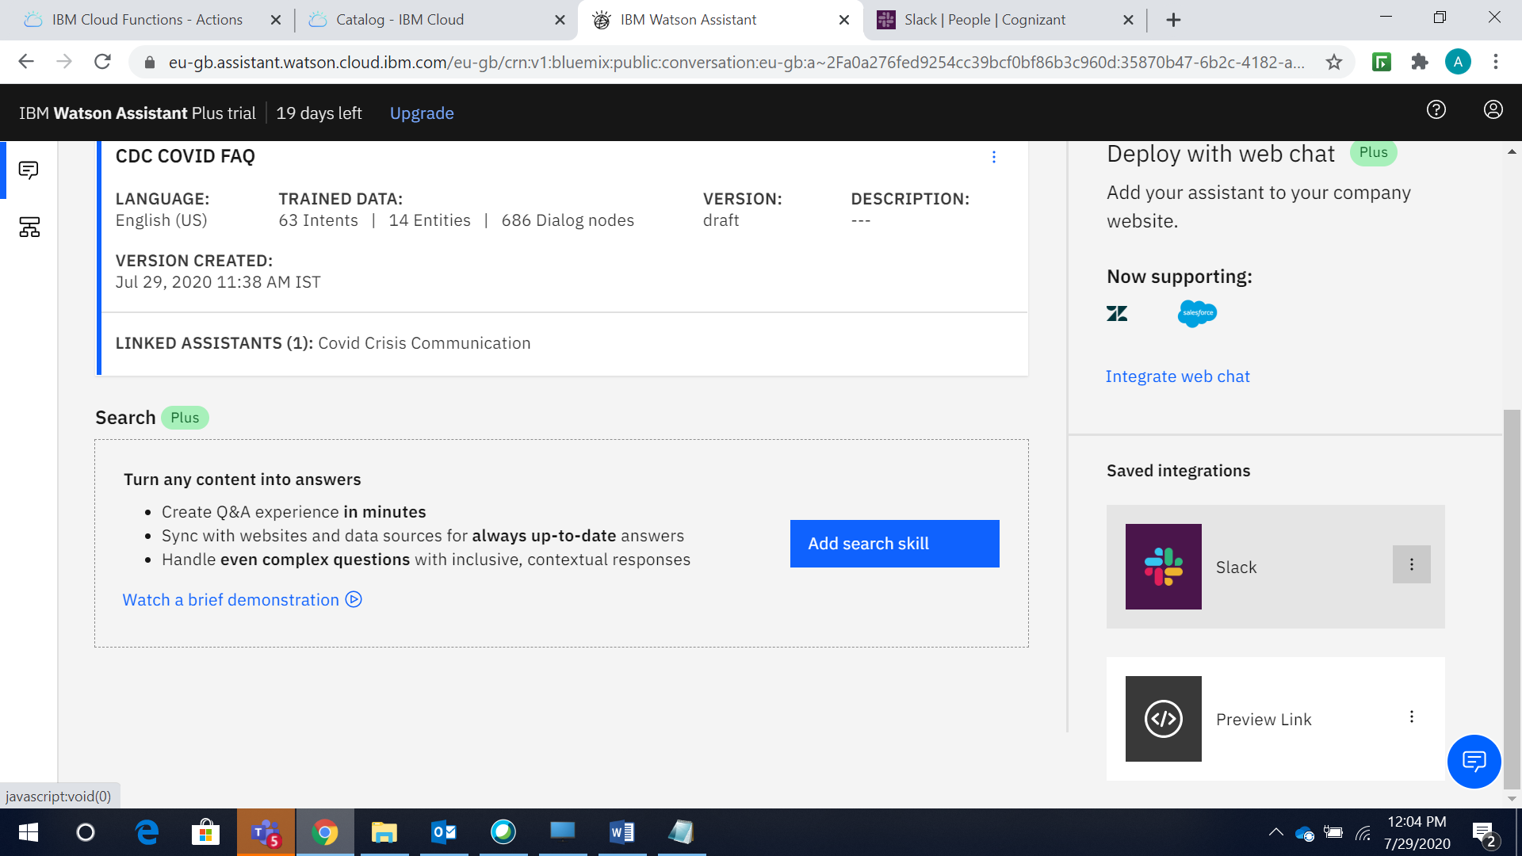

Our Slack location: <https://app.slack.com/client/T016M0MDM8C/D017Y8KGCTW>

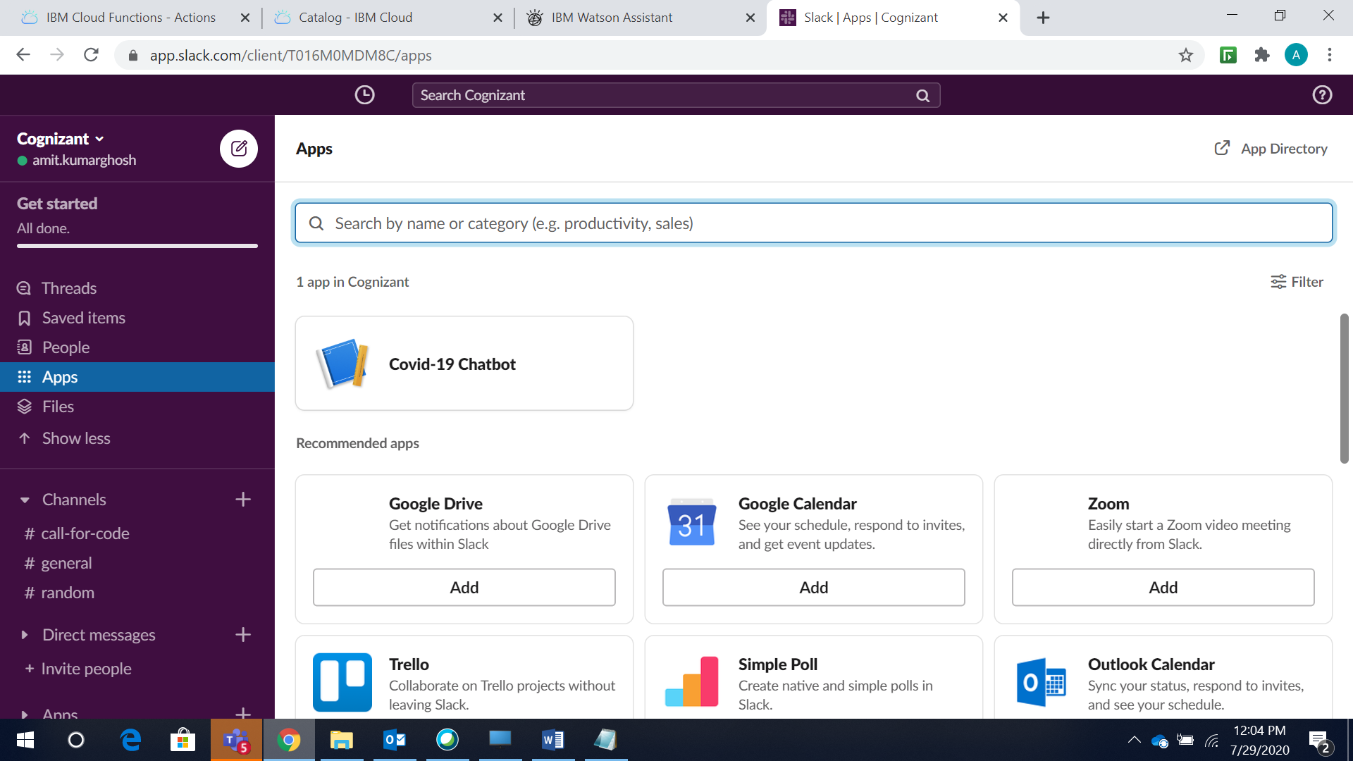

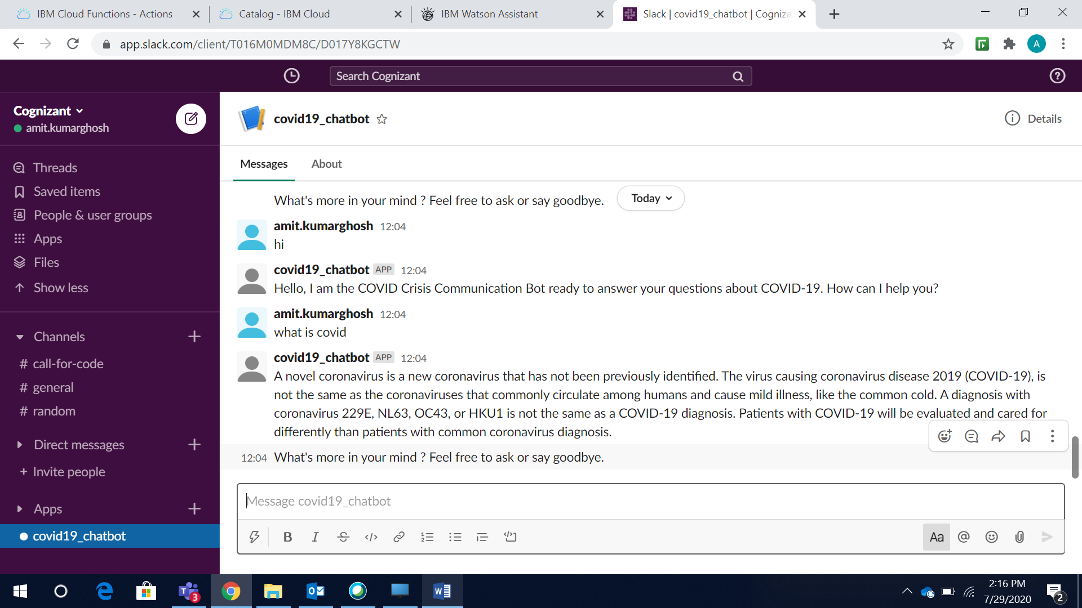

**Embed your COVID-19 Chabot on a Node.js website**

Now, you can embed your COVID-19 crisis communication chatbot on a Node.js website. You connected to a COVID-19 chatbot using the Watson Assistant APIs.

We have follow the below link for integration guidance

* <https://developer.ibm.com/tutorials/create-a-covid-19-chatbot-embedded-on-a-website/>

Here is our outcome

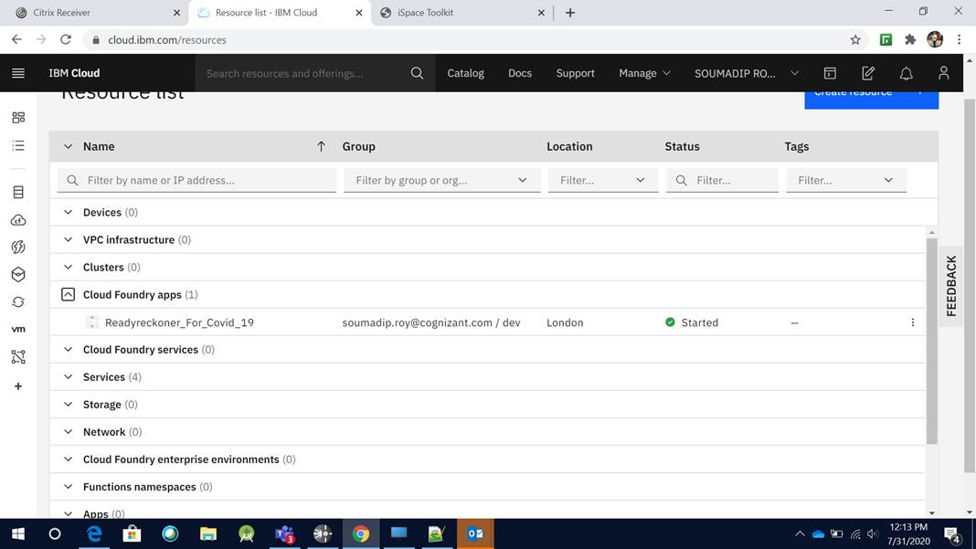

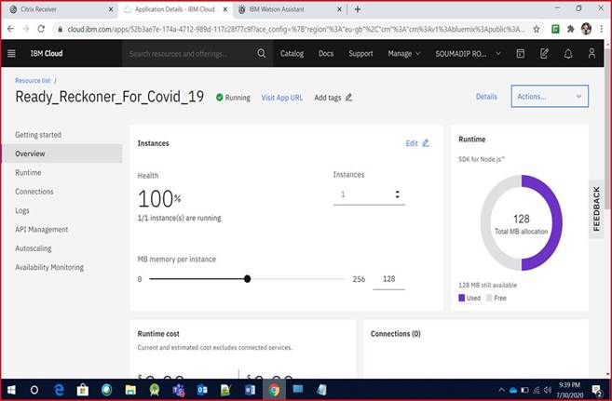

Our Node.js link: <https://readyreckonerforcovid19.eu-gb.mybluemix.net/>

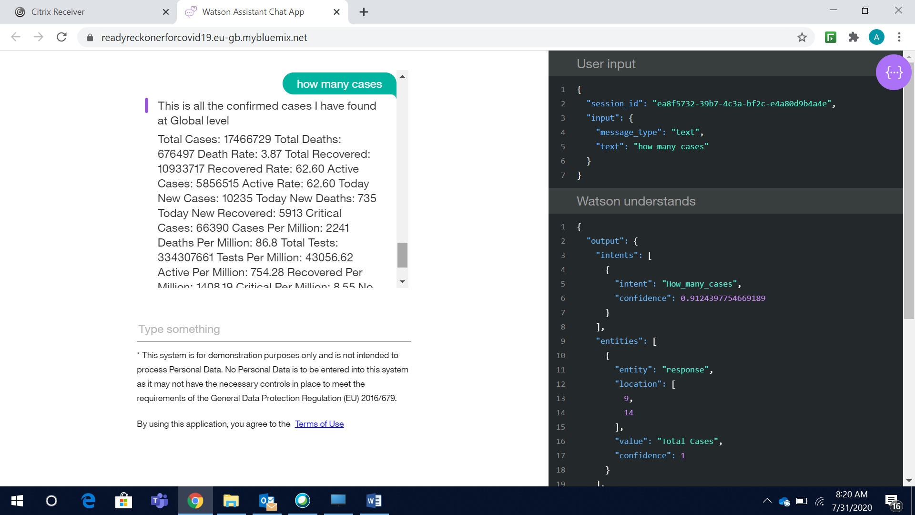

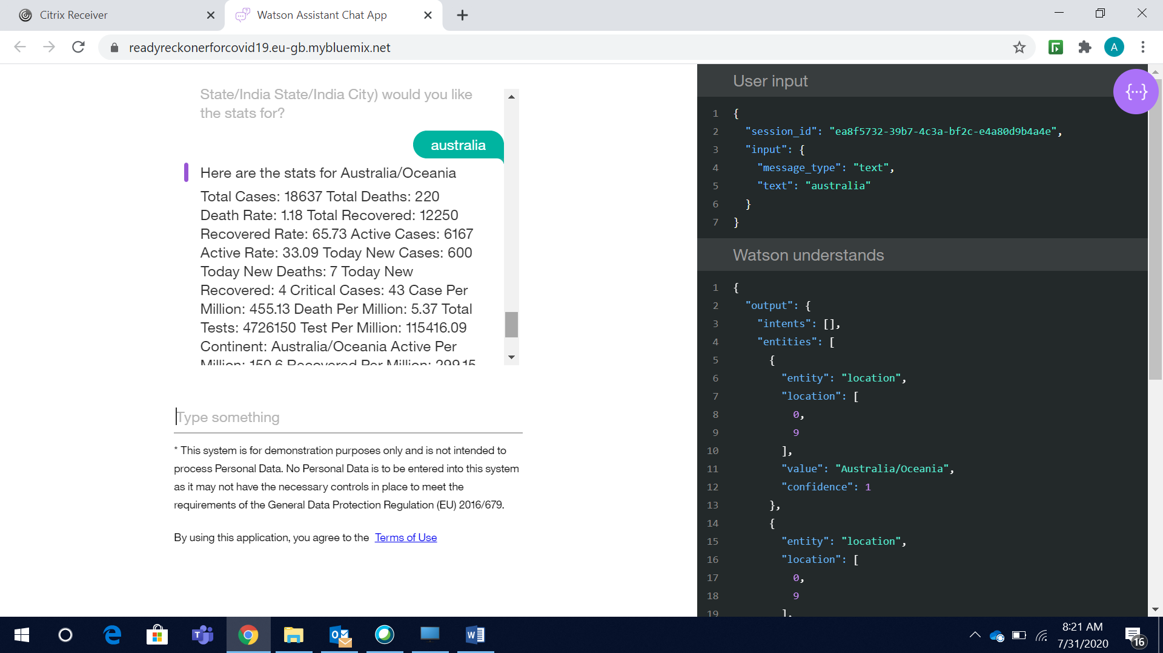

**Android integration with COVID-19 crisis communication Chabot**

Now you can create a voice-enabled Android-native chatbot with Watson Assistant, Text to Speech and Speech to Text services on IBM Cloud®.

We have follow the below link for integration guidance

* <https://cloud.ibm.com/docs/solution-tutorials?topic=solution-tutorials-android-watson-chatbot>

Here is our outcome

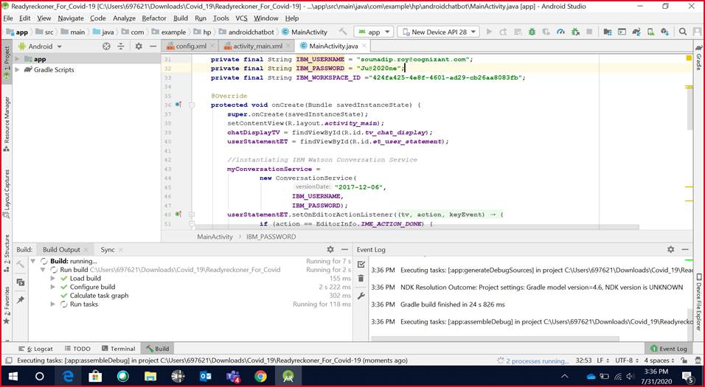

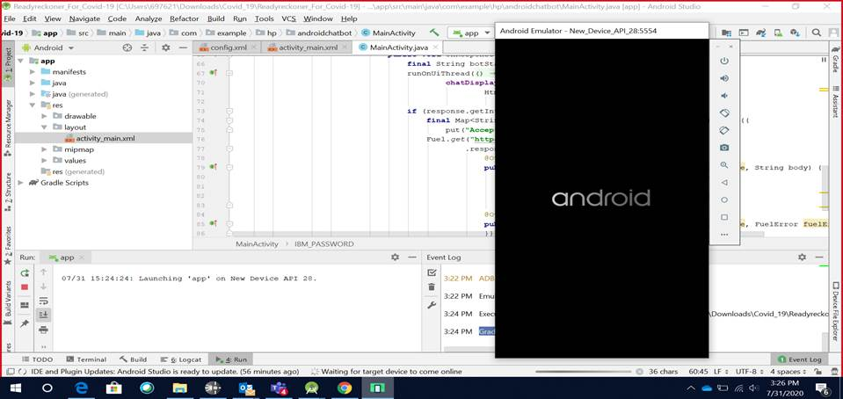

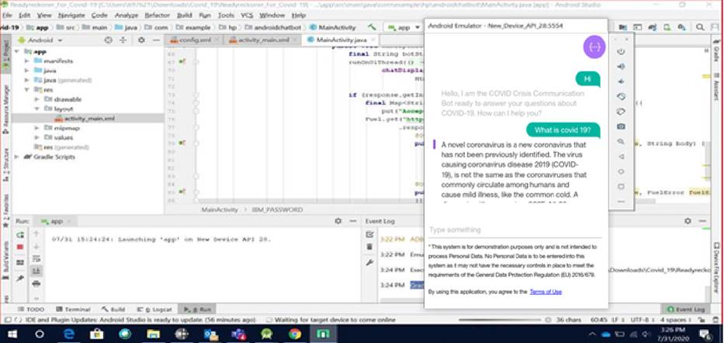

## Disclosures

This tool is intended to provide information based on currently available on various reliable sites and other public information to help you make decisions about seeking appropriate medical care. This system is not intended for the diagnosis or treatment of disease or other conditions, including COVID-19, and you should not provide any personally identifying or private health information.

This Watson Assistant bot is populated with data that is sourced from the below resource

* Most static responses provide information found on the CDC's Covid FAQ Page: <https://www.cdc.gov/coronavirus/2019-ncov/faq.html> & WHO sites & various other Govt. sites.
* Dynamic infection and total cases, active cases, death counts and other various data insights are sourced via the following API:
  + **Global/Country/Continent/Region level data** --> Worldometers (https://corona.lmao.ninja/v2/all & https://corona.lmao.ninja/v2/countries & <https://corona.lmao.ninja/v2/continents>)
  + **India State & City level data** -->[MyGov](https://cognizantonline-my.sharepoint.com/personal/319998_cognizant_com/Documents/Desktop/Hackathon/MyGov) Website & COVID19India MOHFW Gov. Org.Media(https://covid-19india-api.herokuapp.com/v2.0/state_data & https://api.covid19india.org/state_district_wise.json)
  + **US State level data** -->Data from New York Times(https://corona.lmao.ninja/v2/states)
  + **Covid Helpline Details**-->https://www.mohfw.gov.in & <https://www.mygov.in/covid-19/>
  + **Country Level Travel Advisory**--> www.travel-advisory.info for respective countries("https://www.travel-advisory.info/api)
  + **Testing counts and other information**-->ICMR data and various states bulletin
  + **Hospitals ,Beds,ICU & Ventilator information**-->https://cddep.org/wp-content/uploads/2020/04/State-wise-estimates-of-current-beds-and-ventilators_24Apr2020.pdf
* Dynamic news stories are sourced from Watson Discovery's news feed. Additional information on that service can be found here: https://www.ibm.com/watson/services/discovery-news

## Scope for Enhancement

* Integrate the chatbot to various other additional public data sources ,subject matter expertise & more API’s to create a complete robust solution
* Build a real time customized UI with many more interactive features
* Integrate the chatbot with iOS

